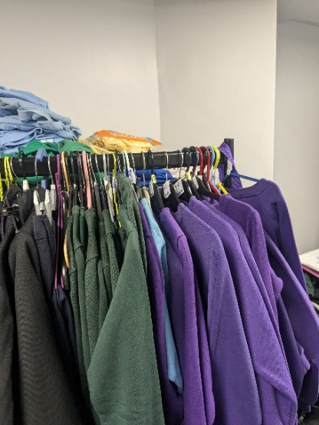
Case Study
Living Well Schools – Poverty
Uniform Swap Shop – South Bradford, Holme Wood
Two local residents wanted to support parents on the Holme Wood estate who may be struggling to afford uniforms. They approached Lauren Batty, the CEO of OutLOUD and Founder of Beyond the Margin CIO. Lauren suggested they apply for funding from Holme Wood Together, the community safety partnership.
The two residents applied and gained £600 to support the project. Lauren supported the residents with the process of establishing the project by coordinating with a designer to make a logo and poster and coordinate publicity. The residents organised a Facebook group and contacted local schools and residents to acquire donations of preloved uniform. They started by collecting, filtering, and washing all the uniforms. They were then able to secure a space in the TFD library where they store and distribute the uniform, which also supports the donation drop process as they were originally collecting and storing it themselves.
They used the funding to buy new uniforms, which helped ensure a range of sizes. It also allowed them to get fully equipped pencil cases, hygiene packs, and support with washing the uniforms. Volunteers run the space and have systems in place to check stock and capture the reach.
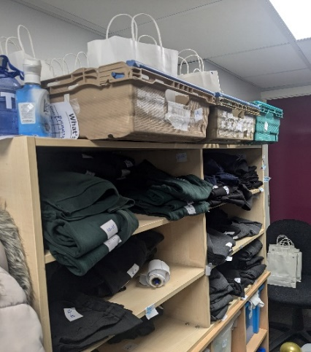
Holme Wood Uniform Swap Shop launched at a fun day at the TFD centre run by OutLOUD and Bradford Council’s Youth Service in July 2024. It has been well attended since, offering a range of opening times to ensure all families can access the service.
The benefits include alleviating massive pressure from parents that has been felt across the community. Families are now fully equipped for going back to school. Other benefits include reducing the number of uniforms going to landfills. The full effects of the initiative will be shown in September. To date Holme Wood Uniform Swap Shop has supported 70 households and distributed 136 items of uniform.

