Living Well Schools
Eating Well Workshop Part 1
Day Xth Month: XX:XX – XX:XX

Learning Objectives:
- What does healthy mean to you?
- Benefits of a balanced diet
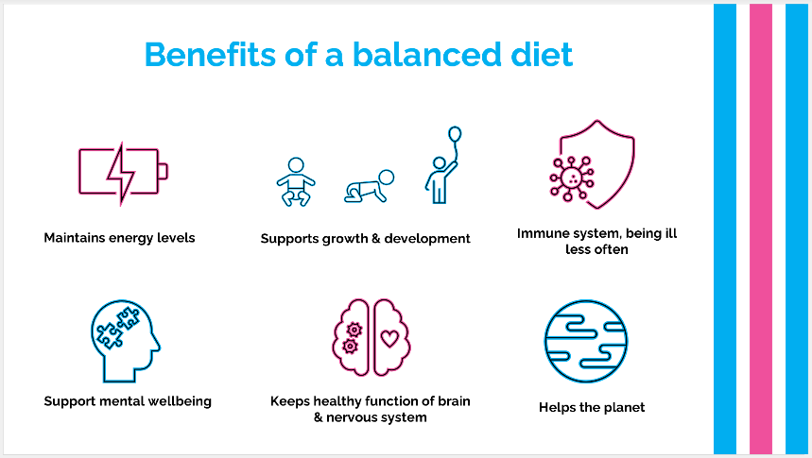
- Eatwell Guide
- Importance of fibre, vitamins & minerals and vitamin D
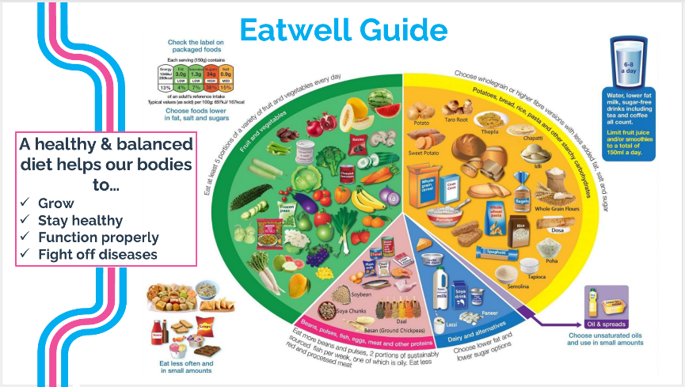
- Food group activity

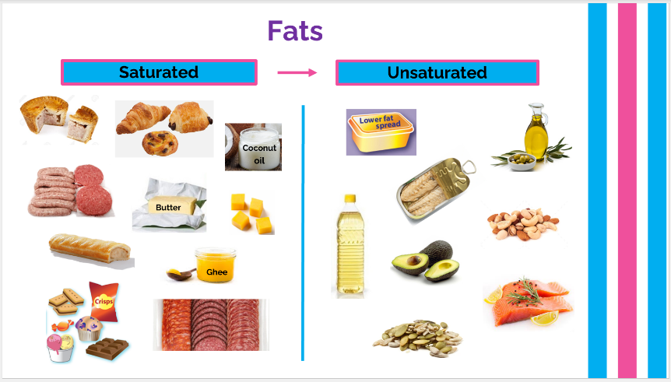
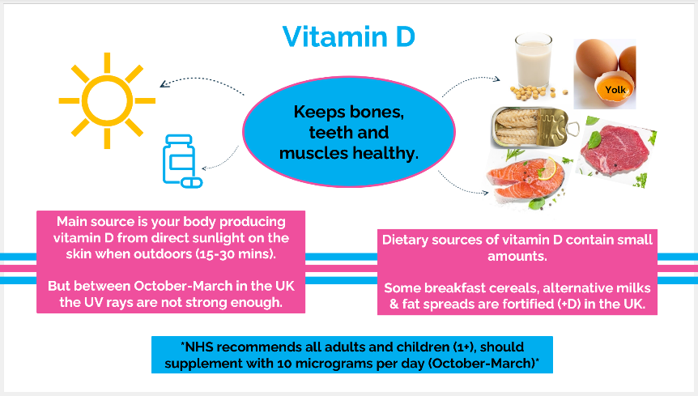

Living Well Schools
Eating Well Workshop Part 2
Day Xth Month: XX:XX – XX:XX

Learning Objectives:
- Sugar recommendations
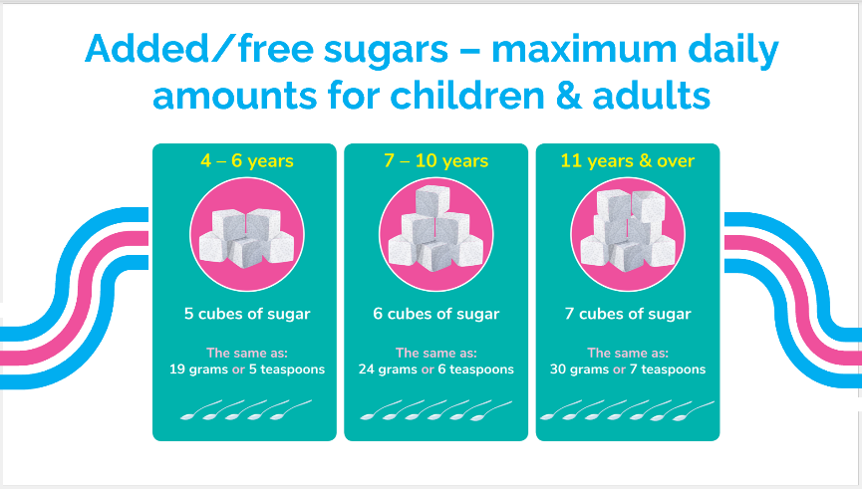
- Understanding food labels
- Healthy swaps & alternatives
- Bradfords packed lunch toolkit
