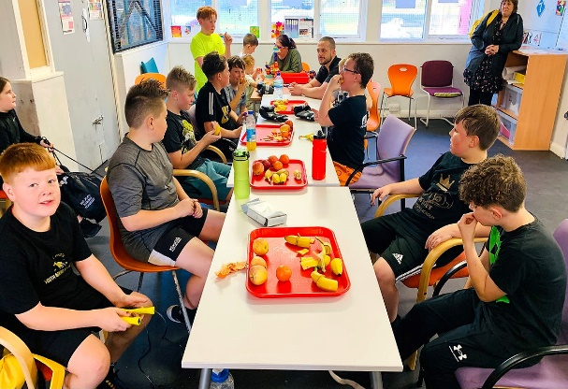
Case Study
Living Well School Area – Eating Well & Poverty
Saif Space Breakfast Provision – Buttershaw Youth Centre
Saif Space is a charity running out of the Buttershaw Youth Centre. It runs a community café called café South, along with boxing sessions.
When delivering boxing sessions, they wanted to incorporate healthy eating into it, they contacted a local organisation that supplied them with fruit for the session. Within these sessions, it was noticed that one child was eating quickly and stealing the fruit. After talking to the school to investigate why, they uncovered the issue that many families were struggling financially but not meeting the threshold for Free School Meals as had working parents.
From this Saif Space CIC was created. There was a kitchen in the youth centre which had been gifted to them by Wrens Kitchens that was not being used to its full potential, which has now become the home of Café South where the income gained supported the running of the breakfast club.
To make this happen, Saif was supported by Participate in setting up the organisation, and the Youth Centre, allowed them to use their space. They contacted the school to make an ongoing argument about timing, and Buttershaw Business & Enterprise College donates £60 worth of food when needed as it sees the breakfast club as a valued intervention. To attend the breakfast club, the children must have a membership that outlines the GDPR, Safeguarding, and “House Rules.” This helps to create a supportive environment for the children where children understand the behaviour expectations of the breakfast club. There is also an expectation around attendance where the school communicates with the breakfast club so that a conversation can be had.
This has resulted in the attendance of children significantly increasing their attendance with children on Pupil Premium reaching now 93% and other children reaching 95%. It also reduces hunger for vulnerable children.
Funding has been difficult to secure throughout the process. Some funding has been secured but to overcome this the breakfast club is run by volunteers form the local community and Saif is working with a bid writer to support in acquiring new funds.

