Table of Contents
JU:MP Schools Approach 1
JU:MP Universal Schools Offer - Opportunities 2
In-school CAS Lead Training 2
27th of January: 1pm-4pm, University of Bradford. 2
Online Webinars: 2
12th of February: JUMP and CAS programme news, updates, and opportunities. 2
26th of February: Additional initiatives and opportunities for your schools. 2
Physical Education Community of Practice: 10th March 2026, 9am-3.30pm, University of Bradford. 3
JUMP Schools and National Partners Community of Practice: 19th May 2026 (post SATS), University of Bradford. 3
Open Afternoons: 3
Active Enrichment: Poplars Farm (Karl Morris), 26th March 2026, 1-3pm: 3
Active Travel: High Crags (Carla Goodey), Date and time TBC: 3
Opening School Facilities: TBC. 3

JU:MP Schools Approach
The JU:MP Schools Approach - a community of practice to improve whole-school physical activity across Bradford.
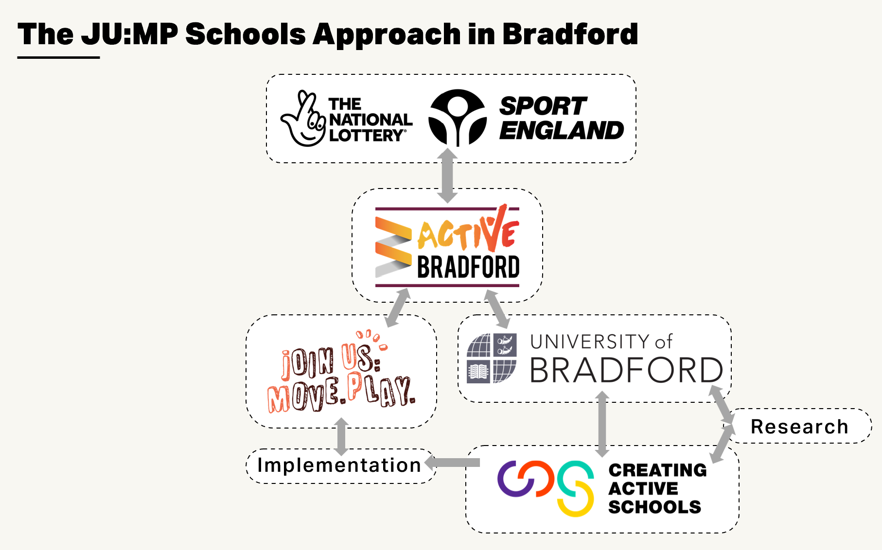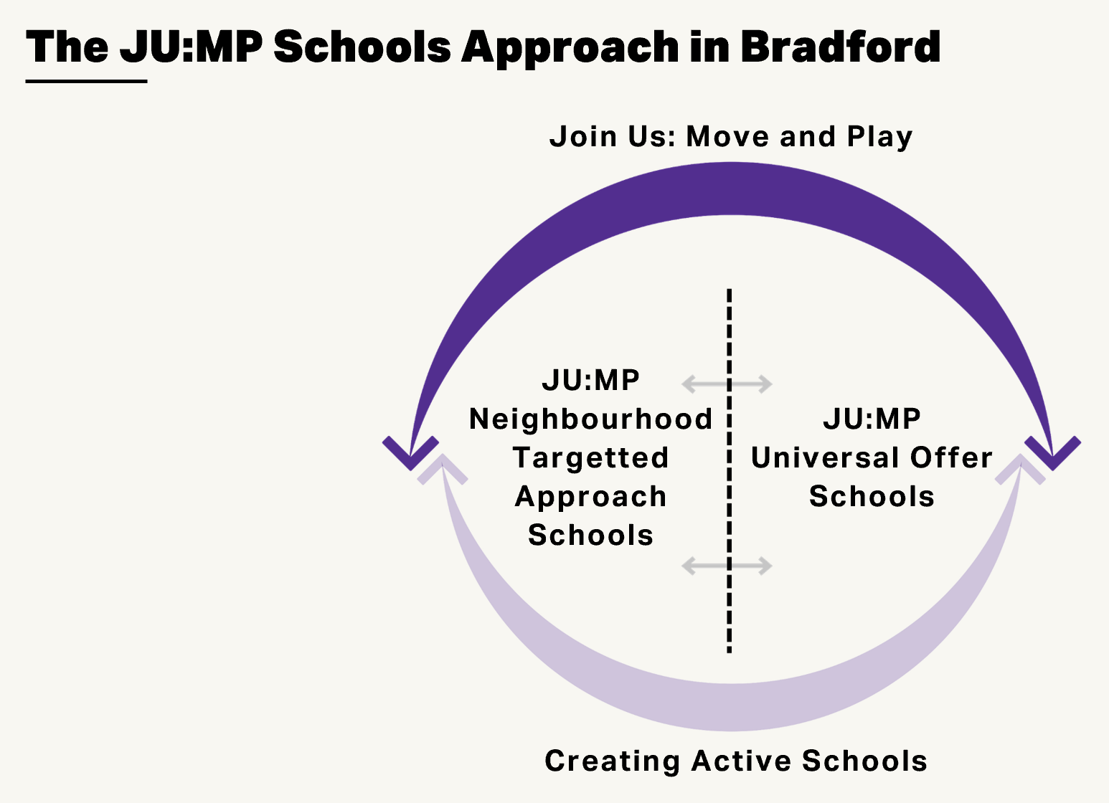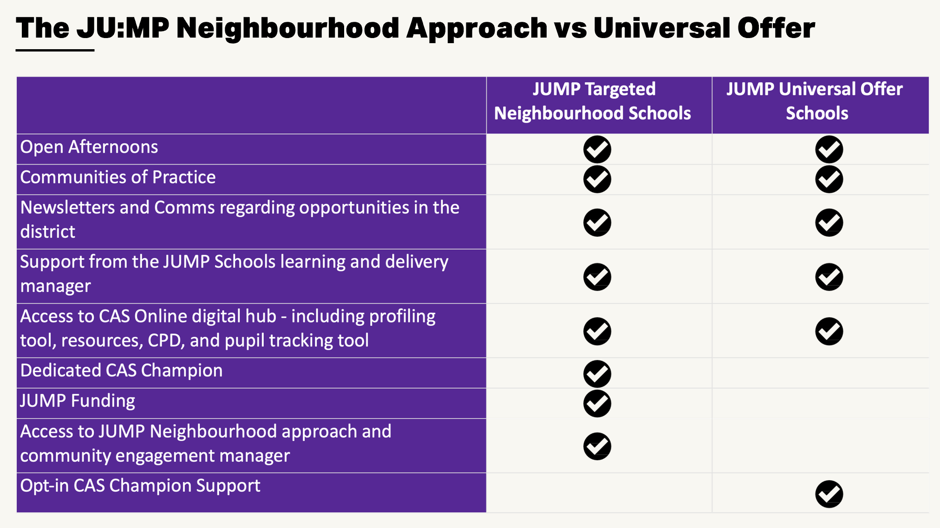

JU:MP Universal Schools Offer - Opportunities
Reminder of the exciting opportunities JUMP have coming up for the rest of the academic year.
Please note, in response to feedback regarding difficulties attending set days/times, webinars will now be pre-recorded and shared on the outlined dates.
Key contact: jump-schools@bradford.ac.uk
In-school CAS Lead Training
27th of January: 1pm-4pm, University of Bradford. We really encourage anyone that is new in the role as an in-school CAS lead, have additional staff to be trained, or are interesting in repeating this training to sign up and attend. The event will offer learning into the CAS programme and annual cycle, insights into the different roles, stakeholders, and opportunities for support, time for networking between schools, and opportunities for questions. Please sign up here: In-School CAS Lead Training - 27th January 1pm-4pm – Fill in form. Please note that you will need to complete this form even if you already had completed the sign-up for the original community of practice. New training dates added, upon programme engagement and registration demand.
Online Webinars: We will be hosting the below pre-recorded webinars to provide you with updates, and opportunities. Webinars can still be shared after date release date.
12th of February: JUMP and CAS programme news, updates, and opportunities. This is a fantastic opportunity to reconnect as our JUMP school’s community and re-ignite our collective movement to improving whole-school physical activity provision to support all pupils to be more physically active throughout the day. The webinar will include information on the JUMP programme, its delivery moving forward, and opportunities for you to connect, learn, and share with the local community and Bradford eco-system the JUMP programme has worked to build. In addition, updates and opportunities through the JUMP Schools offer, such as the open afternoons (detailed lower in the email), CAS pupil tracking tool, upcoming events, Physical Activity Projects, and funding opportunities for your school.
26th of February: Additional initiatives and opportunities for your schools. This will include presentations from a Bradford-based representative of the GB Triathlon initiative swim, bike, run who can support schools in developing and delivering active opportunities for children and families in school and the community, and our active travel offer. This encompasses support from Carla, one of our resident CAS Champions who has developed assemblies for parents and families, the Modeshift active travel initiative which now has a dedicated Bradford lead to support schools in developing and implementing their active travel initiative, and the May JUMP to school week.
Physical Education Community of Practice: 10th March 2026, 9am-3.30pm, University of Bradford. Based on selected priorities and identified areas of need, we have decided to put on a PE centric community of practice. This will include keynotes covering the national policy landscape for PE, the integration of PE and movement into the curriculum, assessing PE, and practical sessions to trial different pedagogies and learning strategies for PE. Further information to follow! Please sign up here: PE Community of Practice - 10th March 2026 – Fill in form
JUMP Schools and National Partners Community of Practice: 19th May 2026 (post SATS), University of Bradford. We are hosting a community of practice focused on sharing learning between schools within Bradford and within the broader CAS ecosystem. Being a part of national programme, we have an exciting opportunity to learn from other schools and regions on tackling diverse inequalities and implementing initiatives suited to individual contexts and settings. This event will aim to draw on this learning and establish connections that support the development of tailored solutions in your schools. In addition, it will provide opportunity for you to influence what CAS will look like in the coming years, engage in diverse CPD offers and, and connect with your local schools. Please sign up here: JUMP Schools MAY Community of Practice – Fill in form
Open Afternoons: We recognise that a real strength of the JUMP Schools network is the sharing of learning and opportunities to see physical activity provision in action. Therefore, two schools have kindly agreed to host open afternoons to share specific tailored solutions relating to one (or more) components of the CAS Framework, see below for more information. Please note that due to limited spaces, these will be given on a first come, first served basis. Ensure you sign up to avoid missing out!
Active Enrichment: Poplars Farm (Karl Morris), 26th March 2026, 1-3pm: Insights into their Active Enrichment offer, and adaptations for one-form and two-form entry schools. Active Enrichment is an exciting shift in thinking, offering all pupils diverse and enriching active opportunities in place of one PE lesson a week. Please sign up here: Active Enrichment Open Afternoon - 26th March – Fill in form
Active Travel: High Crags (Carla Goodey), Date and time TBC: Updating and adapting your active travel offer. Carla has been leading on a project aimed to shift thinking around active travel and engage pupils in delivering assemblies for parents and families. Connecting in with Modeshift and the walk to school week.

Opening School Facilities: TBC.

