20 Minute Movement Workplaces - Social Media Planner Page 1
Platform | Message | Image
Twitter | An active body helps create a healthy mind!  We’ve joined the 20 Minute Movement to help our staff be healthier!  Sign your workplace up now!  FREE resources to download!  https://online1.snapsurveys.com/mh38q6  (Limited printed resources also available)  #20MinMove www.mylivingwell.co.uk | 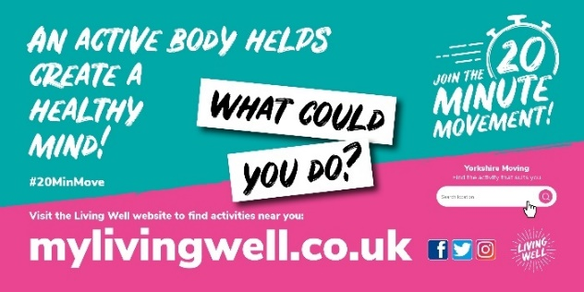
Alt text | An active body helps create a healthy mind! Join the 20 Minute Movement. Visit the Living Well website and use the activity portal to find activities near you. What could you do? www.mylivingwell.co.uk
Facebook | An active body helps create a healthy mind!  We’ve joined the 20 Minute Movement to help our staff be healthier!  With FREE resources available to download or a printed pack of resources - it's easy to join!  Sign up your workplace!  https://online1.snapsurveys.com/mh38q6  (Limited printed copies available)  www.mylivingwell.co.uk | 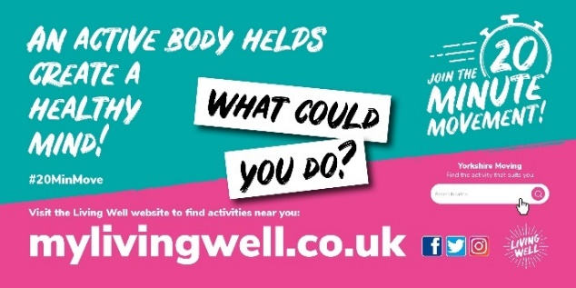
Alt text | An active body helps create a healthy mind! Join the 20 Minute Movement. Visit the Living Well website and use the activity portal to find activities near you. What could you do? www.mylivingwell.co.uk
Instagram | An active body helps create a healthy mind!  We’ve joined the 20 Minute Movement to help our staff be healthier!  With FREE resources available to download or a printed pack of resources - it's easy to join! Sign up your workplace!  www.mylivingwell.co.uk  #20MinMove  #motivation #health #lifestyle #fitnessmotivation #healthylifestyle #exercise | 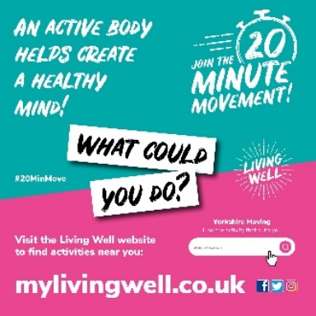
20 Minute Movement Workplaces - Social Media Planner Page 2
Platform | Message | Image
Twitter | #Bradford Walk to Work Day - 17th April!  Join in and walk for at least 20mins!  Park a bit further away from work or get off the bus/train a stop early! You could do 10 mins in the morning & 10 mins in the evening!  Join the 20 Minute Movement!  www.mylivingwell.co.uk  #20MinMove | 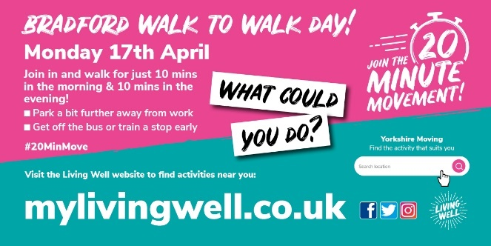
Alt text | Bradford Walk to Work Day! Join in and walk for just 10 mins in the morning & 10 mins in the evening! Park a bit further away from work or get off the bus/train a stop early! Join the 20 Minute Movement. Visit our website and use the activity portal to find activities near you. What could you do? www.mylivingwell.co.uk
Facebook | #Bradford Walk to Work Day - 17th April!  Join in and walk for at least 20mins!  Park a bit further away from work or get off the bus/train a stop early! You could do 10 mins in the morning & 10 mins in the evening!  Join the 20 Minute Movement!  www.mylivingwell.co.uk  #20MinMove
Alt text | Bradford Walk to Work Day! Join in and walk for just 10 mins in the morning & 10 mins in the evening! Park a bit further away from work or get off the bus/train a stop early! Join the 20 Minute Movement. Visit our website and use the activity portal to find activities near you. What could you do? www.mylivingwell.co.uk
Instagram | #Bradford Walk to Work Day - 17th April!  Join in and walk for at least 20mins!  Park a bit further away from work or get off the bus/train a stop early! You could do 10 mins in the morning & 10 mins in the evening!  Join the 20 Minute Movement!  www.mylivingwell.co.uk  #20MinMove  #motivation #health #lifestyle #fitnessmotivation #healthylifestyle #exercise | 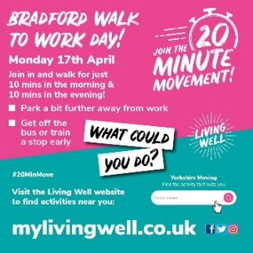
20 Minute Movement Workplaces - Social Media Planner Page 3
Platform | Message | Image
Twitter | Sitting for a long time (eg at a desk) isn't great for health. We're cutting time spent sitting & breaking up long periods of not moving. Using the stairs & moving more to get our hearts working!  We're active at work!  https://online1.snapsurveys.com/mh38q6  #20MinMove  www.mylivingwell.co.uk | 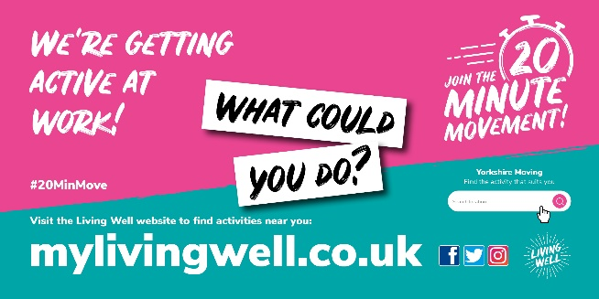
Alt text | We’re getting active at work! Join the 20 Minute Movement. Visit the Living Well website and use the activity portal to find activities near you. What could you do? www.mylivingwell.co.uk
Facebook | Sitting for a long time (eg at a desk) isn't great for our health. We’ve joined the 20 Minute Movement to help our staff cut time spent sitting & breaking up long periods of not moving with some activity. We’re using the stairs and moving around to get our hearts working!  We’re getting active at work!  https://online1.snapsurveys.com/mh38q6  www.mylivingwell.co.uk | 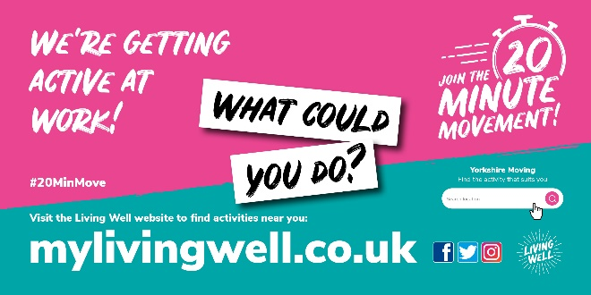
Alt text | We’re getting active at work! Join the 20 Minute Movement. Visit the Living Well website and use the activity portal to find activities near you. What could you do? www.mylivingwell.co.uk
Instagram | Sitting for a long time (eg at a desk) isn't great for our health. We’ve joined the 20 Minute Movement to help our staff cut time spent sitting & breaking up long periods of not moving with some activity. We’re using the stairs and moving around to get our hearts working!  We’re getting active at work!  www.mylivingwell.co.uk  #20MinMove  #motivation #health #lifestyle #fitnessmotivation #healthylifestyle #exercise | 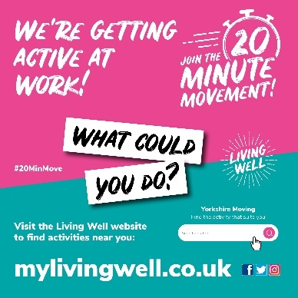
20 Minute Movement Workplaces - Social Media Planner Page 4
Platform | Message | Image
Twitter | We're helping our staff to be active & healthy at work! We've joined the 20 Minute Movement!  Adults should be moving for at least 150 mins per week with activities that increase heart rate, that’s just 20 mins a day!  https://online1.snapsurveys.com/mh38q6  #20MinMove  www.mylivingwell.co.uk | 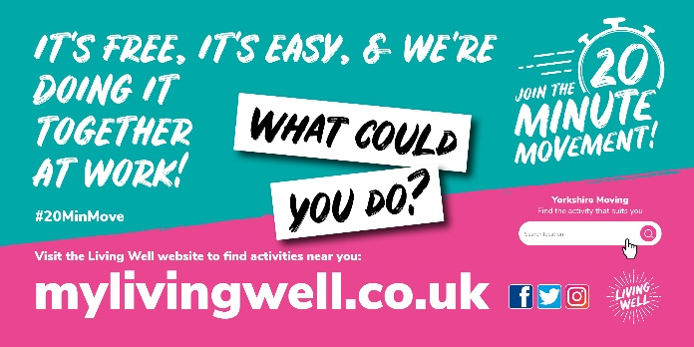
Alt text | It’s free, it’s easy and we’re doing it together at work! Join the 20 Minute Movement. Visit our website and use the activity portal to find activities near you. What could you do? www.mylivingwell.co.uk
Facebook | We're helping our staff to be active & healthy at work! We've joined the 20 Minute Movement!  Adults should be moving for at least 150 mins per week with activities that increase heart their rate, that’s just 20 mins a day!  Help your staff by signing up here:  https://online1.snapsurveys.com/mh38q6  www.mylivingwell.co.uk
Alt text | It’s free, it’s easy and we’re doing it together at work! Join the 20 Minute Movement. Visit our website and use the activity portal to find activities near you. What could you do? www.mylivingwell.co.uk
Instagram | We're helping our staff to be active & healthy at work!  We've joined the 20 Minute Movement!  Adults should be moving for at least 150 mins per week with activities that increase heart their rate, that’s just 20 mins a day!  Help your staff by signing up here:www.mylivingwell.co.uk  #20MinMove  #motivation #health #lifestyle #fitnessmotivation #healthylifestyle #exercise | 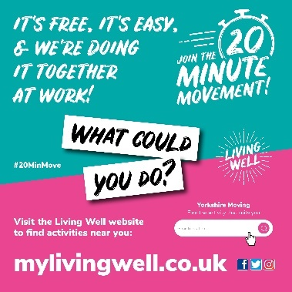
20 Minute Movement Workplaces - Social Media Planner Page 5
Platform | Message | Image
Twitter | We’re encouraging our staff to move for 20mins every day to help them be active & healthy. We've joined the 20 Minute Movement!  Adults should be moving for at least 150mins a week that’s just 20 mins a day!  Sign up here  https://online1.snapsurveys.com/mh38q6  #20MinMove  www.mylivingwell.co.uk | 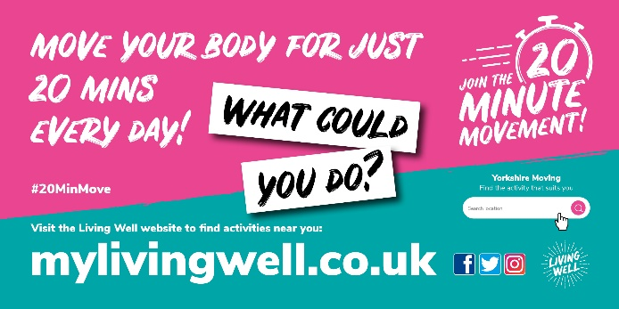
Alt text | Move your body for just 20 mins every day! Join the 20 Minute Movement. Visit our website and use the activity portal to find activities near you. What could you do? www.mylivingwell.co.uk
Facebook | We’re encouraging our staff to move for 20 mins every day to help them be active & healthy at work! We've joined the 20 Minute Movement!  Adults should be moving for at least 150 mins per week with activities that increase heart rate, that’s just 20 mins a day!  Help your staff by signing up here:  https://online1.snapsurveys.com/mh38q6  www.mylivingwell.co.uk
Alt text | Move your body for just 20 mins every day! Join the 20 Minute Movement. Visit our website and use the activity portal to find activities near you. What could you do? www.mylivingwell.co.uk
Instagram | We’re encouraging our staff to move for 20 mins every day to help them be active & healthy at work! We've joined the 20 Minute Movement!  Adults should be moving for at least 150 mins per week with activities that increase heart rate, that’s just 20 mins a day!  Help your staff by signing up here:  www.mylivingwell.co.uk  #20MinMove  #motivation #health #lifestyle #fitnessmotivation #healthylifestyle #exercise | 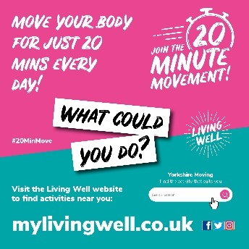

20 Minute Movement Workplaces - Social Media Planner Page 6
Platform | Message | Image
Twitter | We’re encouraging our staff to move for 20 mins every day to help them be active & healthy at work! We've joined the 20 Minute Movement!  What do you do at your workplace? We'd love to share ideas!  Sign up your workplace https://online1.snapsurveys.com/mh38q6  #20MinMove  www.mylivingwell.co.uk | 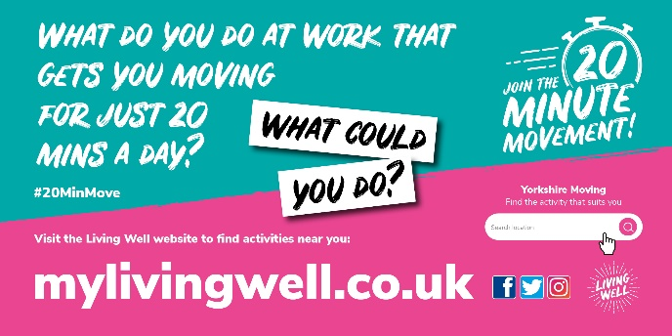
Alt text | What do you do at work that gets you moving for just 20 minutes every day? Join the 20 Minute Movement. Visit our website and use the activity portal to find activities near you. What could you do? www.mylivingwell.co.uk
Facebook | We’re encouraging our staff to move for 20 mins every day to help them be active & healthy at work!  We've joined the 20 Minute Movement!  What do you do at your workplace? We'd love to share ideas!  Help your staff by signing up here:  https://online1.snapsurveys.com/mh38q6  www.mylivingwell.co.uk
Alt text | What do you do at work that gets you moving for just 20 minutes every day? Join the 20 Minute Movement. Visit our website and use the activity portal to find activities near you. What could you do? www.mylivingwell.co.uk
Instagram | We’re encouraging our staff to move for 20 mins every day to help them be active & healthy at work!  We've joined the 20 Minute Movement!  What do you do at your workplace? We'd love to share ideas!  Help your staff by signing up here:  www.mylivingwell.co.uk  #20MinMove  #motivation #health #lifestyle #fitnessmotivation #healthylifestyle #exercise | 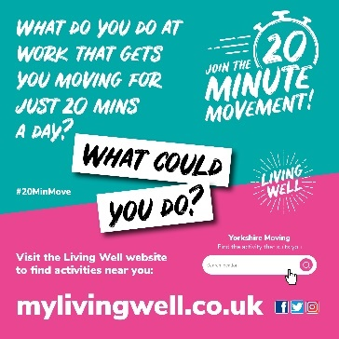
20 Minute Movement Workplaces - Social Media Planner Page 7
Platform | Message | Image
Twitter | We’re encouraging our staff to move for 20 mins every day to help them be active & healthy at work! We've joined the 20 Minute Movement!  Help make time for your staff to move around at work!  Sign up your workplace: https://online1.snapsurveys.com/mh38q6  #20MinMove  www.mylivingwell.co.uk | 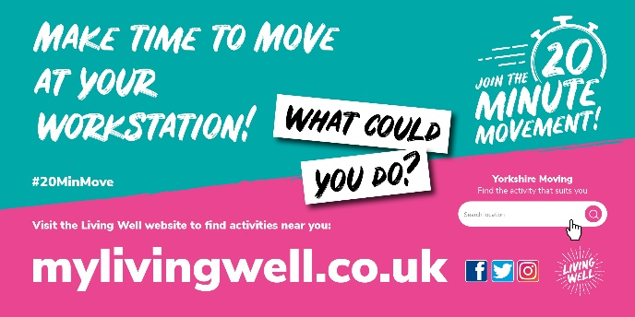
Alt text | What do you do at work that gets you moving for just 20 minutes every day? Join the 20 Minute Movement. Visit our website and use the activity portal to find activities near you. What could you do? www.mylivingwell.co.uk
Facebook | We’re encouraging our staff to move for 20 mins every day to help them be active & healthy at work! We've joined the 20 Minute Movement!  Help make time for your staff to move around at work!  Help your staff by signing up here:  https://online1.snapsurveys.com/mh38q6  www.mylivingwell.co.uk
Alt text | What do you do at work that gets you moving for just 20 minutes every day? Join the 20 Minute Movement. Visit our website and use the activity portal to find activities near you. What could you do? www.mylivingwell.co.uk
Instagram | We’re encouraging our staff to move for 20 mins every day to help them be active & healthy at work! We've joined the 20 Minute Movement!  Help make time for your staff to move around at work!  Help your staff by signing up here:  www.mylivingwell.co.uk  #20MinMove  #motivation #health #lifestyle #fitnessmotivation #healthylifestyle #exercise | 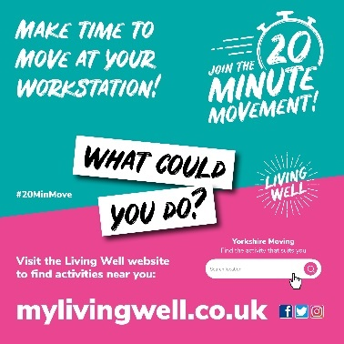
20 Minute Movement Workplaces - Social Media Planner Page 8
Platform | Message | Image
Twitter | Jog on the spot while the kettle boils – help make break time active!  We’re encouraging our staff to move for 20 mins every day to help them be active & healthy at work!  Sign up your workplace to the 20 Minute Movement: https://online1.snapsurveys.com/mh38q6  #20MinMove  www.mylivingwell.co.uk | 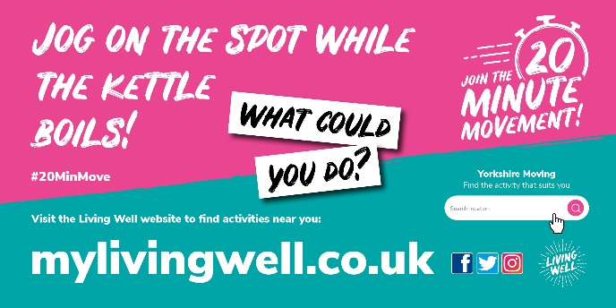
Alt text | Jog on the spot while the kettle boils! Join the 20 Minute Movement. Visit our website and use the activity portal to find activities near you. What could you do? www.mylivingwell.co.uk
Facebook | Jog on the spot while the kettle boils – help make break time active!  We’re encouraging our staff to move for 20 mins every day to help them be active & healthy at work! We've joined the 20 Minute Movement!  Help make time for your staff to move around at work!  Help your staff by signing up here:  https://online1.snapsurveys.com/mh38q6  www.mylivingwell.co.uk
Alt text | Jog on the spot while the kettle boils! Join the 20 Minute Movement. Visit our website and use the activity portal to find activities near you. What could you do? www.mylivingwell.co.uk
Instagram | Jog on the spot while the kettle boils – help make break time active!  We’re encouraging our staff to move for 20 mins every day to help them be active & healthy at work! We've joined the 20 Minute Movement!  Help make time for your staff to move around at work!  Help your staff by signing up here:  www.mylivingwell.co.uk  #20MinMove  #motivation #health #lifestyle #fitnessmotivation #healthylifestyle #exercise | 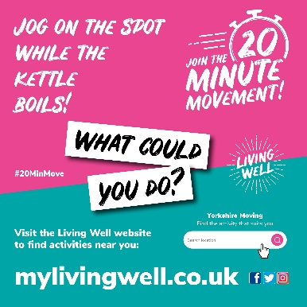
20 Minute Movement Workplaces - Social Media Planner Page 9
Platform | Message | Image
Twitter | We’re encouraging our staff to clear their heads with a lunchtime walk! Moving for just 20 mins every day can help them to be more active & healthier at work!  We've joined the 20 Minute Movement!  Sign up your workplace: https://online1.snapsurveys.com/mh38q6  #20MinMove  www.mylivingwell.co.uk | 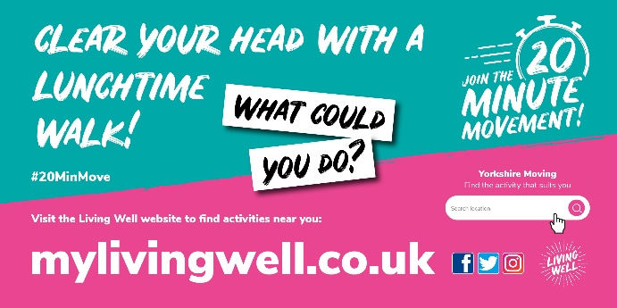
Alt text | Clear your head with a lunchtime walk! Join the 20 Minute Movement. Visit our website and use the activity portal to find activities near you. What could you do? www.mylivingwell.co.uk
Facebook | We’re encouraging our staff to clear their heads with a lunchtime walk! Moving for just 20 mins every day can help them to be more active & healthier at work!  We've joined the 20 Minute Movement!  Help your staff by signing up here:  https://online1.snapsurveys.com/mh38q6  www.mylivingwell.co.uk
Alt text | Clear your head with a lunchtime walk! Join the 20 Minute Movement. Visit our website and use the activity portal to find activities near you. What could you do? www.mylivingwell.co.uk
Instagram | We’re encouraging our staff to clear their heads with a lunchtime walk! Moving for just 20 mins every day can help them to be more active & healthier at work!  We've joined the 20 Minute Movement!  Help your staff by signing up here:  www.mylivingwell.co.uk  #20MinMove  #motivation #health #lifestyle #fitnessmotivation #healthylifestyle #exercise | 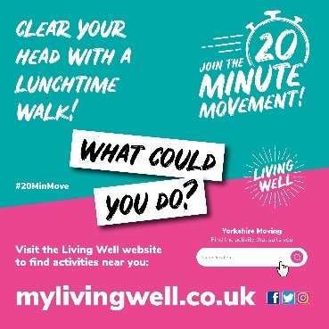
20 Minute Movement Workplaces - Social Media Planner Page 10
Platform | Message | Image
Twitter | Where possible - we’re encouraging our staff to arrange some walking meetings! We want to help them move for 20 mins every day to help them be active & healthy at work!  Sign up your workplace to the 20 Minute Movement: https://online1.snapsurveys.com/mh38q6  #20MinMove  www.mylivingwell.co.uk | 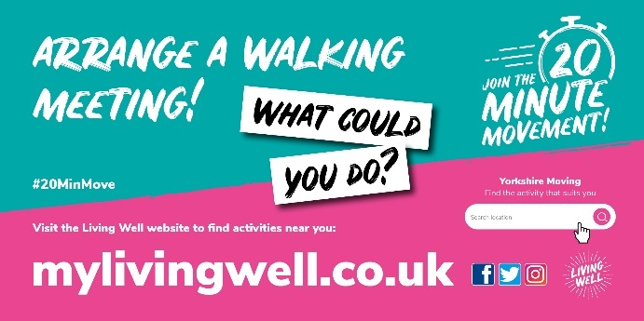
Alt text | Arrange a walking meeting! Join the 20 Minute Movement. Visit our website and use the activity portal to find activities near you. What could you do? www.mylivingwell.co.uk
Facebook | Where possible - we’re encouraging our staff to arrange some walking meetings! We want to help them move for 20 mins every day to help them be active & healthy at work!  We've joined the 20 Minute Movement!  Help your staff by signing up here:  https://online1.snapsurveys.com/mh38q6  www.mylivingwell.co.uk
Alt text | Arrange a walking meeting! Join the 20 Minute Movement. Visit our website and use the activity portal to find activities near you. What could you do? www.mylivingwell.co.uk
Instagram | Where possible - we’re encouraging our staff to arrange some walking meetings! We want to help them move for 20 mins every day to help them be active & healthy at work!  We've joined the 20 Minute Movement!  Help your staff by signing up here:  www.mylivingwell.co.uk  #20MinMove  #motivation #health #lifestyle #fitnessmotivation #healthylifestyle #exercise | 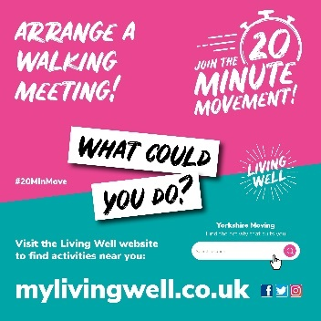
20 Minute Movement Workplaces - Social Media Planner Page 11
Platform | Message | Image
Twitter | We’re encouraging our staff to be as active & healthy as possible - no need for fancy trainers or gyms, it’s easy! Join the 20 Minute Movement to find ways to help staff move for at least 20 mins every day!  Sign up here: https://online1.snapsurveys.com/mh38q6  #20MinMove  www.mylivingwell.co.uk | 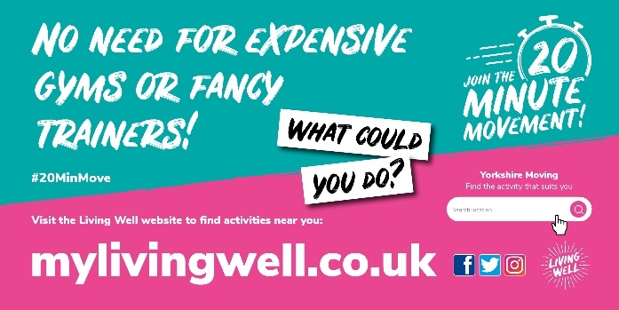
Alt text | No need for expensive gyms or fancy trainers! Join the 20 Minute Movement. Visit our website and use the activity portal to find activities near you. What could you do? www.mylivingwell.co.uk
Facebook | We’re encouraging our staff to be as active & healthy as possible - no need for fancy trainers or gyms, it’s easy! Join the 20 Minute Movement to find ways to help staff move for at least 20 mins every day!  We've joined the 20 Minute Movement!  Help your staff by signing up here:  https://online1.snapsurveys.com/mh38q6  www.mylivingwell.co.uk
Alt text | No need for expensive gyms or fancy trainers! Join the 20 Minute Movement. Visit our website and use the activity portal to find activities near you. What could you do? www.mylivingwell.co.uk
Instagram | We’re encouraging our staff to be as active & healthy as possible - no need for fancy trainers or gyms, it’s easy! Join the 20 Minute Movement to find ways to help staff move for at least 20 mins every day!  We've joined the 20 Minute Movement!  Help your staff by signing up here:  www.mylivingwell.co.uk  #20MinMove  #motivation #health #lifestyle #fitnessmotivation #healthylifestyle #exercise | 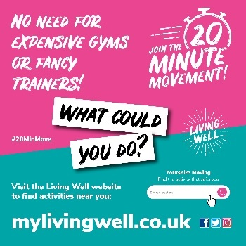
20 Minute Movement Workplaces - Social Media Planner Page 12
Platform | Message | Image
Twitter | To be active during #Ramadan, go for a walk before breaking your fast or go in the evening so you can eat and drink afterwards. Why not invite family and friends to join you?  www.mylivingwell.co.uk  #20MinMove | 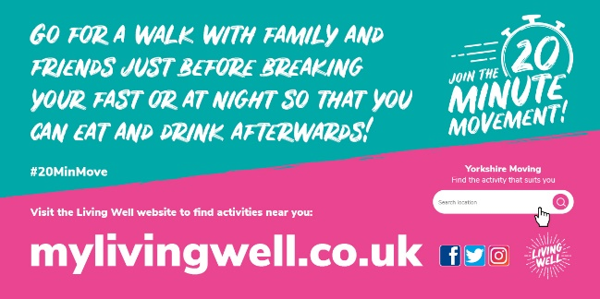
Alt text | During Ramadan go for a walk with family and friends just before breaking your fast or at night so that you can eat and drink afterwards! Join the 20 Minute Movement. Visit our website and use the activity portal to find activities near you. What could you do? www.mylivingwell.co.uk
Facebook | If you want to be active during Ramadan, go for a walk before breaking your fast or go in the evening so you can eat and drink afterwards. Why not invite family and friends to join you?  www.mylivingwell.co.uk | 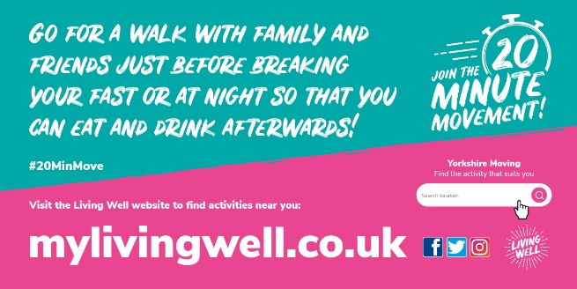
Alt text | During Ramadan go for a walk with family and friends just before breaking your fast or at night so that you can eat and drink afterwards! Join the 20 Minute Movement. Visit our website and use the activity portal to find activities near you. What could you do? www.mylivingwell.co.uk
Instagram | If you want to be active during Ramadan, go for a walk before breaking your fast or go in the evening so you can eat and drink afterwards. Why not invite family and friends to join you?  www.mylivingwell.co.uk  #20MinMove  #Ramadan #Fasting #motivation #health #lifestyle #fitnessmotivation #healthylifestyle #exercise | 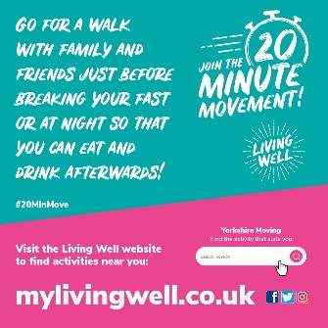
20 Minute Movement Workplaces - Social Media Planner Page 13
Platform | Message | Image
Twitter | During #Ramadan It’s still good for your health & wellbeing to be active but find a time and an activity that suits you.  To find local activities near you, just add your postcode to the ‘Yorkshire Moving’ Portal at the bottom of our home page  www.mylivingwell.co.uk  #20MinMove | 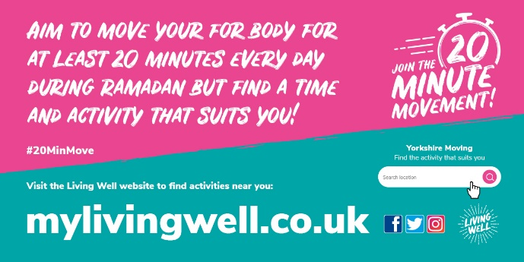
Alt text | Aim to move your body for at least 20 minutes every day during Ramadan but find a time and activity that suits you! Join the 20 Minute Movement. Visit our website and use the activity portal to find activities near you. What could you do? www.mylivingwell.co.uk
Facebook | During Ramadan It’s still good for your health and wellbeing to be active but find a time and an activity that suits you.  To find local activities near you, just add your postcode to the ‘Yorkshire Moving’ Portal at the bottom of our home page  www.mylivingwell.co.uk
Alt text | Aim to move your body for at least 20 minutes every day during Ramadan but find a time and activity that suits you! Join the 20 Minute Movement. Visit our website and use the activity portal to find activities near you. What could you do? www.mylivingwell.co.uk
Instagram | During Ramadan It’s still good for your health and wellbeing to be active but find a time and an activity that suits you.  To find local activities near you, just add your postcode to the ‘Yorkshire Moving’ Portal at the bottom of our home page  www.mylivingwell.co.uk  #20MinMove  #Ramadan #Fasting #motivation #health #lifestyle #fitnessmotivation #healthylifestyle #exercise | 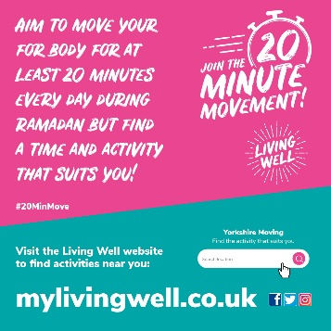
20 Minute Movement Workplaces - Social Media Planner Page 14
Platform | Message | Image
Twitter | Be active during #Ramadan and take the stairs instead of the lift or walk to the shop instead of driving!  Visit our website for lots of other ideas to help you be more active:  www.mylivingwell.co.uk  #20MinMove | 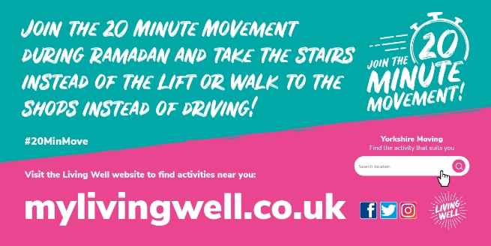
Alt text | Join the 20 Minute Movement during Ramadan and take the stairs instead of the lift or walk to the shop instead of driving! Visit our website and use the activity portal to find activities near you. What could you do? www.mylivingwell.co.uk
Facebook | Be active during Ramadan and take the stairs instead of the lift or walk to the shop instead of driving!  Visit our website for lots of other ideas to help you be more active:  www.mylivingwell.co.uk
Alt text | Join the 20 Minute Movement during Ramadan and take the stairs instead of the lift or walk to the shop instead of driving! Visit our website and use the activity portal to find activities near you. What could you do? www.mylivingwell.co.uk
Instagram | Be active during Ramadan and take the stairs instead of the lift or walk to the shop instead of driving!  Visit our website for lots of other ideas to help you be more active:  www.mylivingwell.co.uk  #20MinMove  #Ramadan #Fasting #motivation #health #lifestyle #fitnessmotivation #healthylifestyle #exercise | 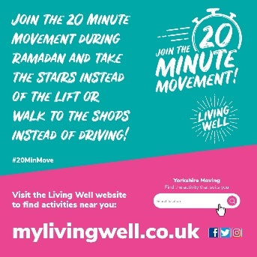

20 Minute Movement Workplaces - Social Media Planner Page 15
Platform | Message | Image
Twitter | During #Ramadan walking briskly for 20 minutes in the evening can be good for your mind and your body!  Visit our website for lots of other ideas to help you be more active:  www.mylivingwell.co.uk  #20MinMove | 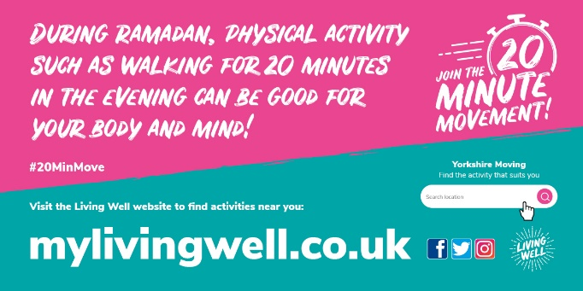
Alt text | During Ramadan walking physical activity such as walking for 20 minutes in the evening can be good for your mind and your body!  Visit our website and use the activity portal to find activities near you. What could you do? www.mylivingwell.co.uk
Facebook | During Ramadan walking briskly for 20 minutes in the evening can be good for your mind and your body!  Visit our website for lots of other ideas to help you be more active:  www.mylivingwell.co.uk
Alt text | During Ramadan walking physical activity such as walking for 20 minutes in the evening can be good for your mind and your body!  Visit our website and use the activity portal to find activities near you. What could you do? www.mylivingwell.co.uk
Instagram | During Ramadan walking briskly for 20 minutes in the evening can be good for your mind and your body!  Visit our website for lots of other ideas to help you be more active:  www.mylivingwell.co.uk  #20MinMove  #Ramadan #Fasting #motivation #health #lifestyle #fitnessmotivation #healthylifestyle #exercise | 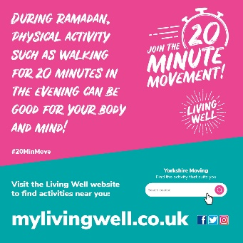

This planner shows a selection of suggested messages using some of the graphics in the activation pack.
If you would like to create your own messages, please tag us @MyLivingWell1 and use the hashtag #20MinMove so that we can like and share too!
If you add our web address, other people can learn more about the 20 Minute Movement – www.mylivingwell.co.uk

