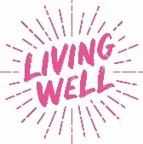
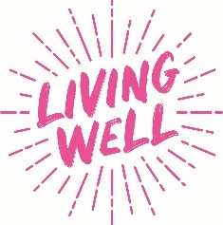
Social Media Planner
Living Well Self Care Week Events - Tues 14th & Thurs 16th November 2023
Graphics for these events are available in the following languages:
Czech / English / Polish
Channel | Message | Image
Twitter | 👋 Come and meet the Living Well team!  We’re offering FREE health checks to celebrate #SelfCareWeek @AiredaleSC  📌 Tues 14 Nov from 11-3pm.  General Health/Physical Activity Referral/Help to Stop Smoking/Blood Pressure Checks/Managing Your Weight & more! www.mylivingwell.co.uk | 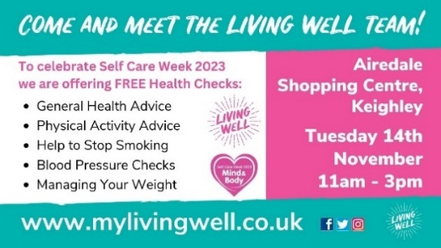
Facebook | 👋 Come and meet the Living Well team!  We’re offering FREE health checks to celebrate #SelfCareWeek @AiredaleShoppingCentre  📌 Tues 14 Nov from 11-3pm.  🔹 General Health Advice  🔹 Physical Activity Referral  🔹 Help to Stop Smoking  🔹 Blood Pressure Checks  🔹 Managing Your Weight & more!  www.mylivingwell.co.uk | 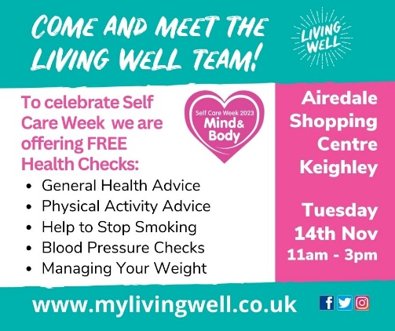
Insta | 👋 Come and meet the Living Well team!  We’re offering FREE health checks to celebrate #SelfCareWeek @AiredaleShoppingCentre  📌 Tues 14 Nov from 11-3pm.  🔹 General Health Advice  🔹 Physical Activity Referral  🔹 Help to Stop Smoking  🔹 Blood Pressure Checks  🔹 Managing Your Weight & more!  www.mylivingwell.co.uk  #health #keighley #selfcare #stopsmoking #bloodpressure #healthylifestyle #healthyliving | 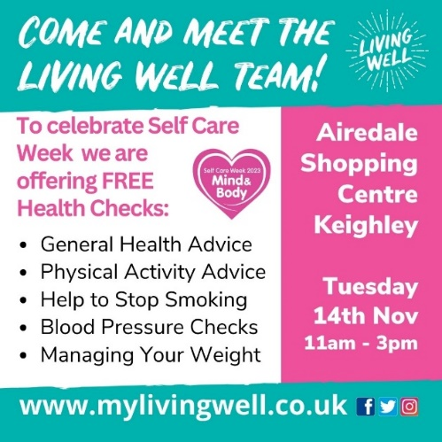
ALT Text | Come and meet the Living Well team! To celebrate Self Care Week 2023 we are offering FREE health checks: General health advice, physical activity advice, help to stop smoking, blood pressure checks, managing your weight. Airedale Shopping Centre Keighley. Tuesday 14 November 11-3pm www.mylivingwell.co.uk
Twitter | 👋 Come and meet the Living Well team!  We’re offering FREE health checks to celebrate #SelfCareWeek @TheBroadwayBrad  📌 Thurs 16 Nov from 11-3pm.  General Health/Physical Activity Referral/Help to Stop Smoking/Blood Pressure Checks/Managing Your Weight & more! www.mylivingwell.co.uk | 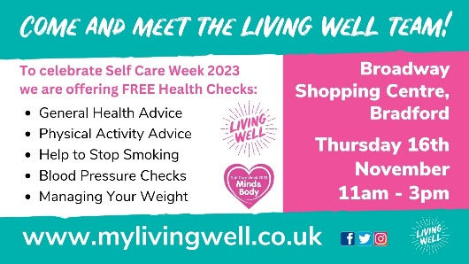
Facebook | 👋 Come and meet the Living Well team!  We’re offering FREE health checks to celebrate #SelfCareWeek @BroadwayShoppingCentre  📌 Thurs 16 Nov from 11-3pm.  🔹 General Health Advice  🔹 Physical Activity Referral  🔹 Help to Stop Smoking  🔹 Blood Pressure Checks  🔹 Managing Your Weight & more!  www.mylivingwell.co.uk | 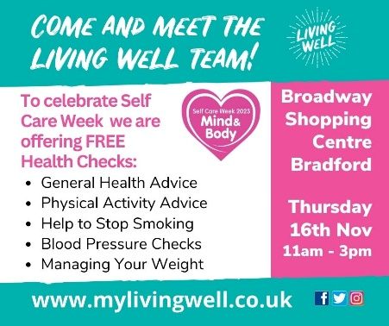
Insta | 👋 Come and meet the Living Well team!  We’re offering FREE health checks to celebrate #SelfCareWeek @BroadwayShoppingCentre  📌 Thurs 16 Nov from 11-3pm.  🔹 General Health Advice  🔹 Physical Activity Referral  🔹 Help to Stop Smoking  🔹 Blood Pressure Checks  🔹 Managing Your Weight & more!  www.mylivingwell.co.uk  #health #keighley #selfcare #stopsmoking #bloodpressure #healthylifestyle #healthyliving | 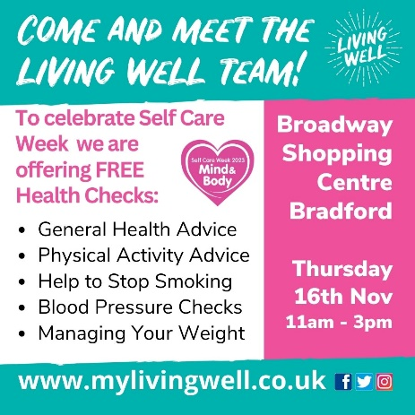
ALT Text | Come and meet the Living Well team! To celebrate Self Care Week 2023 we are offering FREE health checks: General health advice, physical activity advice, help to stop smoking, blood pressure checks, managing your weight. Broadway Shopping Centre Bradford. Thursday 16 November 11-3pm www.mylivingwell.co.uk

