Living Well Grow Well to Eat Well campaign
Social media planner. PLEASE SHARE FROM MARCH 14 2024
If creating your own messages, Please use #GrowWelltoEatWell and tag the following:
Facebook: @MyLivingWell1 @HortonCommunityFarm @GrowBradford
X (Twitter): @MyLivingWell1 @HortonComFarm @GrowBradford
Instagram: @MyLivingWell1 @HortonCommunityFarm @Grow.Bradford

Platform | Message | Suggested Image
Twitter | Fancy having a go at growing your own food?  Try for FREE with @MyLivingWell1  🍅Grow Well to Eat Well! 🥕🥬  There’s nothing tastier than a homegrown tomato!  Visit the website to get your FREE seed pack: www.mylivingwell.co.uk  #GrowWelltoEatWell  @HortonComFarm @GrowBradford | 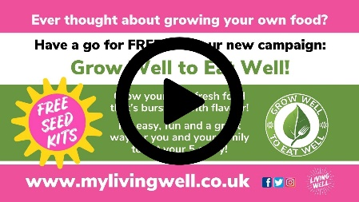  File type: Animated graphic (mp4)  File name: Grow Well to Eat Well Twitter - Animated
Facebook | Have you ever wanted to have a go at growing your own food?  Now you can have a go for FREE with @MyLivingWell1  🍅Grow Well to Eat Well! 🥕🥬  There’s nothing tastier than a homegrown tomato!  Come on Bradford district let’s get growing!  Visit the website to get your FREE seed pack: www.mylivingwell.co.uk  #GrowWelltoEatWell  @HortonCommunityFarm @GrowBradford | 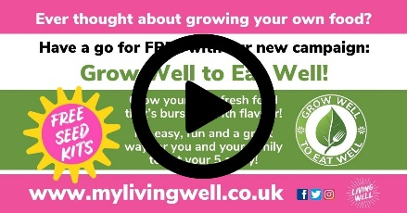  File type: Animated graphic (mp4)  File name: Grow Well to Eat Well Twitter - Animated
Instagram | Have you ever wanted to have a go at growing your own food?  Now you can have a go for FREE with @MyLivingWell1  🍅Grow Well to Eat Well! 🥕🥬  There’s nothing tastier than a homegrown tomato!  Come on Bradford district let’s get growing!  Visit the website to get your FREE seed pack: www.mylivingwell.co.uk  @HortonCommunityFarm  @Grow.Bradford  #GrowWelltoEatWell  #vegetables #grow #growyourown #growyourownfood #homegrown #growyourfood #growwhatyoueat #growfood #growyourownveggies #grownfromseed | File type: Animated graphic (mp4)  File name: Grow Well to Eat Well Instagram - Animated
Alt Text | Ever thought about growing your own food? Have a go for FREE with our new campaign: Grow Well to ﻿Eat Well! Grow your own fresh food that’s bursting with flavour! It’s easy, fun and a great way for you and your family to eat your 5 a day! Ready Set Grow! We’ve teamed up with Horton Community Farm & Grow To School, to offer a free seed growing kit to help you get started! You don’t need a big garden or allotment. You can grow your own food in pots, on your indowsill, balcony, patio or even in a hanging basket! To get you free seed kit visit our website, complete a short form then collect your kit! Choose from 3 types of free kits. Kit 1: Two types of seeds for growing indoors or outdoors Kit 2: Two types of seeds, a pot and compost for growing indoors Kit 3: Three seed packs, a small window box and compost for growing indoors. Kits available to collect from lots of places across Bradford district. Limited stock. What will you grow? www.mylivingwell.co.uk
Twitter | 🍅Grow Well to Eat Well! 🥕🥬  Ever eaten homegrown veg? It’s fresher and tastier!  Have a go for FREE with @MyLivingWell1  Visit the website to get your FREE seed pack!  Come on #Bradford let’s get growing!  www.mylivingwell.co.uk  #GrowWelltoEatWell  @HortonComFarm @growbradford | 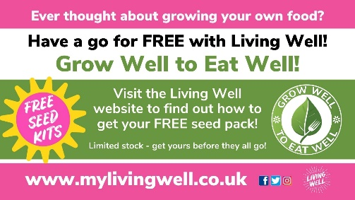  File type: Static graphic (jpg)  File name: Grow Well to Eat Well Twitter – Static 1
Facebook | 🍅Grow Well to Eat Well! 🥕🥬  Have you ever eaten homegrown veg? It’s fresher and tastier!  Now you can have a go for FREE with @MyLivingWell1  Visit the website to get your FREE seed pack: www.mylivingwell.co.uk  Come on Bradford district let’s get growing!  www.mylivingwell.co.uk  #GrowWelltoEatWell  @HortonCommunityFarm @GrowBradford | 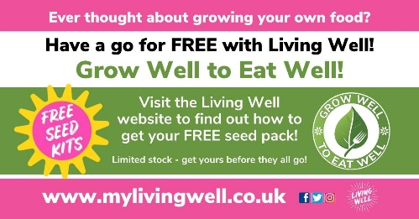  File type: Static graphic (jpg)  File name: Grow Well to Eat Well Facebook – Static 1
Instagram | 🍅Grow Well to Eat Well! 🥕🥬  Have you ever eaten homegrown veg? It’s fresher and tastier!  Now you can have a go for FREE with @MyLivingWell1  Visit the website to get your FREE seed pack and let’s get growing!  www.mylivingwell.co.uk  @HortonCommunityFarm  @Grow.Bradford  #GrowWelltoEatWell  #vegetables #grow #growyourown #growyourownfood #homegrown #growyourfood #growwhatyoueat #growfood #growyourownveggies #grownfromseed | File type: Static graphic (jpg)  File name: Grow Well to Eat Well Instagram – Static 1
Alt Text | Ever thought about growing your own food? Have a go for FREE with our new campaign: Grow Well to ﻿Eat Well! Visit the Living Well website to find out how to get your FREE seed pack! Limited stock - get yours before they all go! www.mylivingwell.co.uk
Twitter | 🍅Grow Well to Eat Well! 🥕  Growing your own veg helps to reduce food waste & saves money too!  Have a go for FREE with @MyLivingWell1  Visit the website to get your FREE seed pack!  Let’s get growing #Bradford!  www.mylivingwell.co.uk  #GrowWelltoEatWell  @HortonComFarm @growbradford | 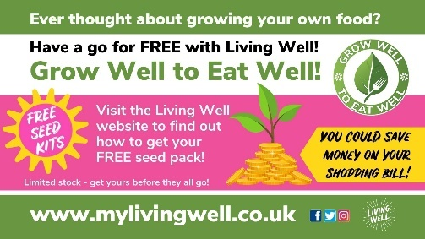  File type: Static graphic (jpg)  File name: Grow Well to Eat Well Twitter – Static 2
Facebook | 🍅Grow Well to Eat Well! 🥕  Growing your own veg helps to reduce food waste and can save money on your shopping bill too!  Have a go for FREE with @MyLivingWell1  Visit the website to get your FREE seed pack!  Let’s get growing #Bradford!  www.mylivingwell.co.uk  #GrowWelltoEatWell  @HortonCommunityFarm @growbradford | 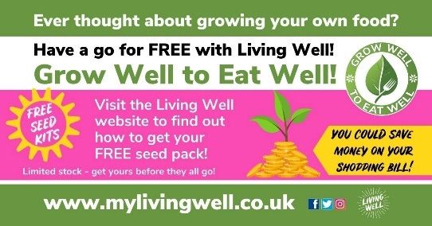  File type: Static graphic (jpg)  File name: Grow Well to Eat Well Facebook – Static 2
Instagram | 🍅Grow Well to Eat Well! 🥕  Growing your own veg helps to reduce food waste and can save money on your shopping bill too!  Have a go for FREE with @MyLivingWell1  Visit the website to get your FREE seed pack!  Let’s get growing #Bradford!  www.mylivingwell.co.uk  @HortonCommunityFarm  @Grow.Bradford  #GrowWelltoEatWell  #vegetables #grow #growyourown #growyourownfood #homegrown #growyourfood #growwhatyoueat #growfood #growyourownveggies #grownfromseed | 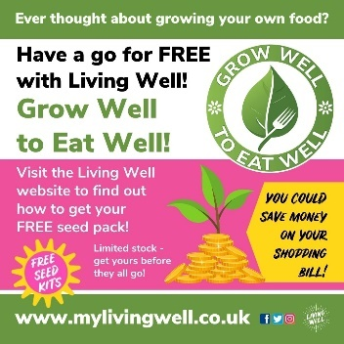  File type: Static graphic (jpg)  File name: Grow Well to Eat Well Instagram – Static 2
Alt Text | Ever thought about growing your own food? Have a go for FREE with our new campaign: Grow Well to ﻿Eat Well! Visit the Living Well website to find out how to get your FREE seed pack! Limited stock - get yours before they all go! You could save money on your shopping bill! www.mylivingwell.co.uk
Twitter | 🍅Grow Well to Eat Well! 🥕  The satisfaction of growing your own food can benefit your mental health!  Have a go FREE with @MyLivingWell1  Visit the website for your FREE seed pack!  Let’s get growing #Bradford  www.mylivingwell.co.uk  #GrowWelltoEatWell  @HortonComFarm @growbradford | 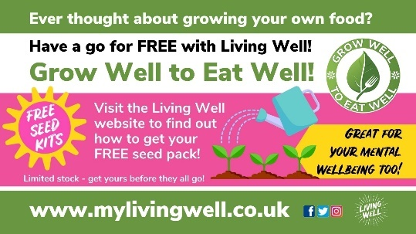  File type: Static graphic (jpg)  File name: Grow Well to Eat Well Twitter – Static 3
Facebook | 🍅Grow Well to Eat Well! 🥕  The satisfaction of growing your own food can benefit your mental health!  Have a go FREE with @MyLivingWell1  Visit the website for your FREE seed pack!  Let’s get growing #Bradford  www.mylivingwell.co.uk  #GrowWelltoEatWell  @HortonCommunityFarm @growbradford | 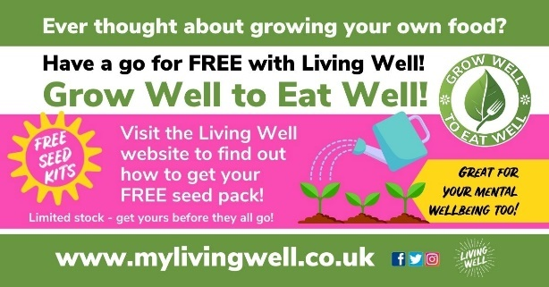  File type: Static graphic (jpg)  File name: Grow Well to Eat Well Facebook – Static 2
Instagram | 🍅Grow Well to Eat Well! 🥕  The satisfaction of growing your own food can benefit your mental health!  Have a go FREE with @MyLivingWell1  Visit the website for your FREE seed pack!  Let’s get growing #Bradford  www.mylivingwell.co.uk  @HortonCommunityFarm  @Grow.Bradford  #GrowWelltoEatWell  #vegetables #grow #growyourown #growyourownfood #homegrown #growyourfood #growwhatyoueat #growfood #growyourownveggies #grownfromseed | 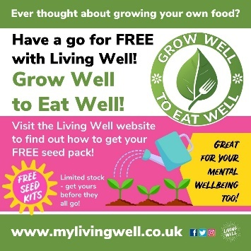  File type: Static graphic (jpg)  File name: Grow Well to Eat Well Instagram – Static 3
Alt Text | Ever thought about growing your own food? Have a go for FREE with our new campaign: Grow Well to ﻿Eat Well! Visit the Living Well website to find out how to get your FREE seed pack! Limited stock - get yours before they all go! Great for your mental wellbieng too! www.mylivingwell.co.uk

If you have any issues or enquiries please contact: communications@mylivingwell.co.uk

