Swap Well to Eat Well - Social Media Planner (Nutrition and Hydration Week - 11-17 March)
Please tag: @MyLivingWell1
Platform | Message | Suggested image
Twitter | 11-17 March is #NutritionandHydrationWeek  Visit us for:  ✔️Ideas, top tips & easy food swaps  ✔️Shopping & cooking meals on a budget  ✔️Tasty low cost recipes  ✔️Food labelling info  ✔️Storing foods for longer  ✔️Lunch box ideas  ✔️Meal planners & shopping lists  https://mylivingwell.co.uk/eating-well/swap-well-to-eat-well/ | Swap Well to Eat Well Animation - Twitter
Facebook | 11-17 March is Nutrition and Hydration Week!  Visit our website to find out about:  ✔️Ideas, top tips & easy food swaps  ✔️Shopping & cooking meals on a budget  ✔️Tasty low cost recipes  ✔️Food labelling info  ✔️Storing foods for longer  ✔️Lunch box ideas  ✔️Meal planners & shopping lists  https://mylivingwell.co.uk/eating-well/swap-well-to-eat-well/ | Swap Well to Eat Well Animation - Facebook
Insta | 11-17 March is #NutritionandHydrationWeek  Visit us to find out about:  ✔️Ideas, top tips & easy food swaps  ✔️Shopping & cooking meals on a budget  ✔️Tasty low cost recipes  ✔️Food labelling info  ✔️Storing foods for longer  ✔️Lunch box ideas  ✔️Meal planners & shopping lists  www.mylivingwell.co.uk  #foodswaps #healthyeating #healthyeatinghabits #healthyeatingtips #healthyeatingideas #healthyeatingmadeeasy #healthyeatinglifestyle #healthyswaps #healthyfoodhacks | Swap Well to Eat Well Animation - Instagram
Alt Text | Swap when you cook, swap when you shop, swap when you snack! Photo of James from Laisterdyke he says “I’m swapping white rice for brown rice. It’s healthier and it keeps me fuller for longer!” Swap half (or all) the mince in your chilli, curry or bolognaise for beans, pulses or lentils. It’s a healthier option and cheaper too! Photo of Shaheen from Ravenscliffe she says “I’m swapping sugary cereals for porridge. It’s healthier, cheaper and keeps my family fuller for longer!” Swap sugary split-pot yoghurts and Rassomalai for natural low fat yoghurt with a handful of fresh or dried fruit. It’s a healthier option and cheaper too! Photo of Mohammed from Manningham he says “I’m swapping crisps and sweets for fruit and vegetables. I’m feeling more energetic and my mood has improved!” Swap crisps and sweets for plain popcorn! Sprinkle your favourite herbs and spices for flavour. It’s a healthier option and cheaper too! Visit www.mylivingwell.co.uk for lots of info on making healthy food swaps.
Twitter | 11-17 March is #NutritionandHydrationWeek  🥤 Swap sugary/fizzy drinks for water - combat tiredness, improve sleep and help your body function better! Not keen on water? Add fresh lemon/lime/strawberries/cucumber or mint! 🍓🍋  Download our info pack here: https://mylivingwell.co.uk/eating-well/swap-well-to-eat-well/ | Swap Well to Eat Well - Twitter 1
Facebook | 11-17 March is Nutrition and Hydration Week!  🥤 Swap sugary/fizzy drinks for water to combat tiredness, improve sleep and help your body function better! Not keen on water? You can add fresh lemon, lime, strawberries, cucumber or mint! 🍓🍋  Download our info pack here: https://mylivingwell.co.uk/eating-well/swap-well-to-eat-well/ | Swap Well to Eat Well - Facebook 1
Instagram | 11-17 March is Nutrition and Hydration Week!  🥤 Swap sugary/fizzy drinks for water to combat tiredness, improve sleep and help your body function better! Not keen on water? You can add fresh lemon, lime, strawberries, cucumber or mint! 🍓🍋  Download our info pack here: https://mylivingwell.co.uk/eating-well/swap-well-to-eat-well/  #NutritionandHydrationWeek #foodswaps #healthyeating #drinkwater #drinkwaterdaily #drinkwaternotsugar #healthyeatinghabits #healthyeatingtips #healthyeatingideas #healthyeatingmadeeasy #healthyeatinglifestyle #healthyswaps #healthyfoodhacks | Swap Well to Eat Well - Instagram 1
Alt Text: | Swap when you cook, swap when you shop, swap when you snack, diagonally across the top of the image. Swap Your Pop! Drinking water instead of sugary or fizzy drinks has SO many benefits! Visit our website to find out what this wonder drink can do for you! mylivingwell.co.uk Good for your body – Good for your mind
Twitter | In this short film, James from Laisterdyke tells us about his easy food swap. James is swapping white rice for brown rice to help keep him fuller for longer!  👀➡️ Watch his film here: https://youtu.be/sEMfJWo4tLc  Find out more: https://mylivingwell.co.uk/eating-well/swap-well-to-eat-well/  #foodswaps  #NutritionandHydrationWeek | Swap Well to Eat Well - Twitter 2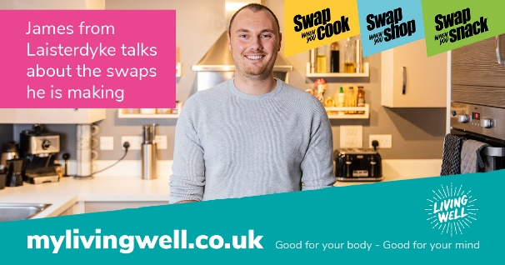
Facebook | In this short film, James from Laisterdyke tells us about his easy food swap. James is swapping white rice for brown rice to help keep him fuller for longer!  👀➡️ Watch his film here: https://youtu.be/sEMfJWo4tLc  Find out more: https://mylivingwell.co.uk/eating-well/swap-well-to-eat-well/  Nutrition and Hydration Week 11-17 March | Swap Well to Eat Well - Facebook 2
Insta | In this short film, James from Laisterdyke tells us about his easy food swap. James is swapping white rice for brown rice to help keep him fuller for longer!  👀➡️ Watch his film here: https://youtu.be/sEMfJWo4tLc  www.mylivingwell.co.uk  #NutritionandHydrationWeek #foodswaps #healthyeating #healthyeatinghabits #healthyeatingtips #healthyeatingideas #healthyeatingmadeeasy #healthyeatinglifestyle #healthyswaps #healthyfoodhacks | Image: Swap Well to Eat Well – Instagram 2  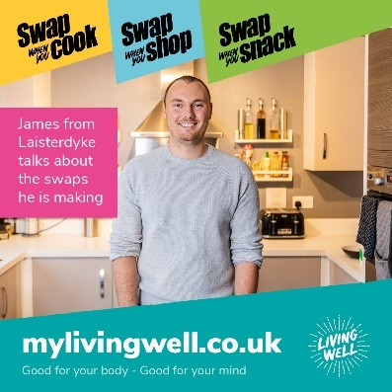
ALT Text | Swap when you cook, swap when you shop, swap when you snack, diagonally across the top of the image. Photo of James in his kitchen smiling into the camera. Pink box with the words; James from Laisterdyke talks about the swaps he is making. mylivingwell.co.uk Good for your body – Good for your mind
Twitter | 11-17 March is #NutritionandHydrationWeek  🥱 Fed up eating the same old meals? Feeling sluggish & need to update your eating habits? Look no further! Get tasty, easy-to-follow, low cost recipes for you & your family!  Download our info pack here: https://mylivingwell.co.uk/eating-well/swap-well-to-eat-well/ | Swap Well to Eat Well - Twitter 3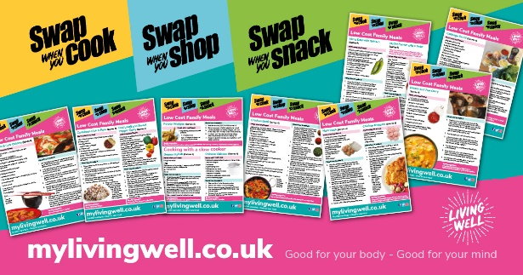
Facebook | 11-17 March is Nutrition and Hydration Week!  🥱 Fed up eating the same old meals? Feeling sluggish and need to update your eating habits? Look no further! Get some tasty, easy-to-follow, low cost recipes for you and your family!  You can find lots of ideas when you download our handy information pack here: https://mylivingwell.co.uk/eating-well/swap-well-to-eat-well/ | Swap Well to Eat Well - Facebook 3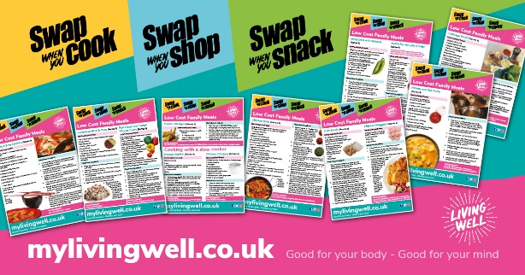
Insta | Getting fed up eating the same old meals? Feeling sluggish and need to update your eating habits? Look no further! Get some tasty, easy-to-follow, low cost recipes for you and your family!  You can find lots of ideas when you download our handy information pack here: www.mylivingwell.co.uk  #NutritionandHydrationWeek #foodswaps #healthyeating #healthyeatinghabits #healthyeatingtips #healthyeatingideas #healthyeatingmadeeasy #healthyeatinglifestyle #healthyswaps #healthyfoodhacks | Swap Well to Eat Well - Instagram 3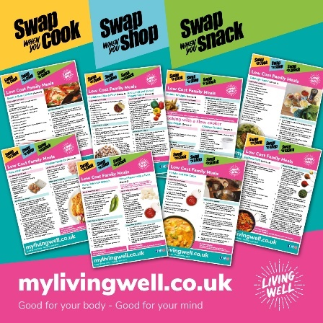
ALT Text | Swap when you cook, swap when you shop, swap when you snack, diagonally across the top of the image Pictures of the recipe cards available in the information pack mylivingwell.co.uk Good for your body – Good for your mind
Twitter | In this short film, Shaheen from Ravenscliffe tells us about her easy food swap. Shaheen is swapping sugary cereal for porridge with fruit.  👀➡️ Watch her film to find out why here: https://youtu.be/BBLcMz1303c  Find out more here: https://mylivingwell.co.uk/eating-well/swap-well-to-eat-well/  #NutritionandHydrationWeek  #foodswaps | Swap Well to Eat Well – Twitter 4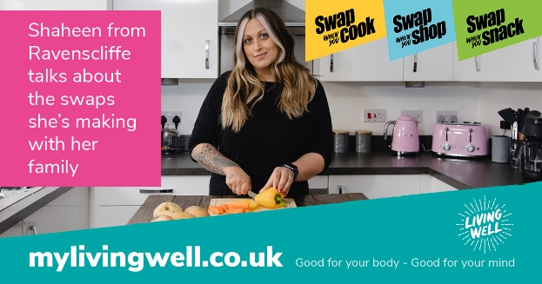
Facebook | In this short film, Shaheen from Ravenscliffe tells us about her easy food swaps. Shaheen is swapping sugary cereal for porridge with fruit.  👀➡️ Watch her film to find out why here: https://youtu.be/BBLcMz1303c  Find out more here: https://mylivingwell.co.uk/eating-well/swap-well-to-eat-well/  Nutrition and Hydration Week 11-17 March | Swap Well to Eat Well – Facebook 4
Insta | In this short film, Shaheen from Ravenscliffe tells us about her easy food swaps. Shaheen is swapping sugary cereal for porridge with fruit. Watch her film to find out why here: https://youtu.be/BBLcMz1303c www.mylivingwell.co.uk  #NutritionandHydrationWeek #foodswaps #healthyeating #healthyeatinghabits #healthyeatingtips #healthyeatingideas #healthyeatingmadeeasy #healthyeatinglifestyle #healthyswaps #healthyfoodhacks | Swap Well to Eat Well – Instagram 4  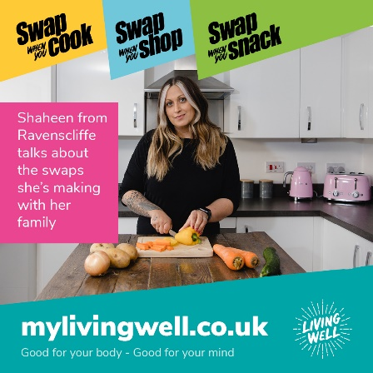
ALT Text | Swap when you cook, swap when you shop, swap when you snack, diagonally across the top of the image. Photo of Shaheen in her kitchen smiling into the camera. Pink box with the words; Shaheen from Ravenscliffe talks about the swaps she is making with her family. mylivingwell.co.uk Good for your body – Good for your mind
Twitter | In this short film, Mohammed from Manningham tells us about the food swaps he and his family are making. Mohammed is making swaps to reduce the crisps and sweets the family eat.  👀➡️ Watch his film here: https://youtu.be/_s8v0Ox6cFI  Find out more here: https://mylivingwell.co.uk/eating-well/swap-well-to-eat-well/  #NutritionandHydrationWeek #foodswaps | Swap Well to Eat Well – Twitter 5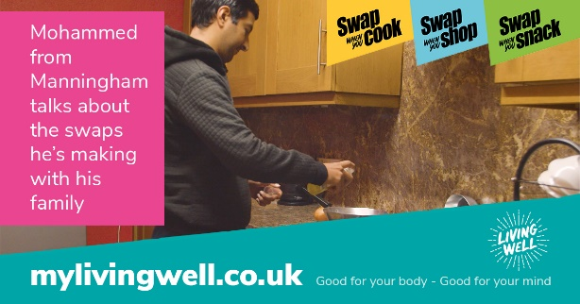
Facebook | In this short film, Mohammed from Manningham tells us about the food swaps he and his family are making. Mohammed is making swaps to reduce the crisps and sweets the family eat.  👀➡️ Watch his film here: https://youtu.be/_s8v0Ox6cFI  Find out more here: https://mylivingwell.co.uk/eating-well/swap-well-to-eat-well/  Nutrition and Hydration Week 11-17 March | Swap Well to Eat Well – Facebook 5
Insta | In this short film, Mohammed from Manningham tells us about the food swaps he and his family are making. Mohammed is making swaps to reduce the crisps and sweets the family eat. Watch his film here: https://youtu.be/_s8v0Ox6cFI  www.mylivingwell.co.uk  #NutritionandHydrationWeek #foodswaps #healthyeating #healthyeatinghabits #healthyeatingtips #healthyeatingideas #healthyeatingmadeeasy #healthyeatinglifestyle #healthyswaps #healthyfoodhacks | Swap Well to Eat Well – Instagram 5  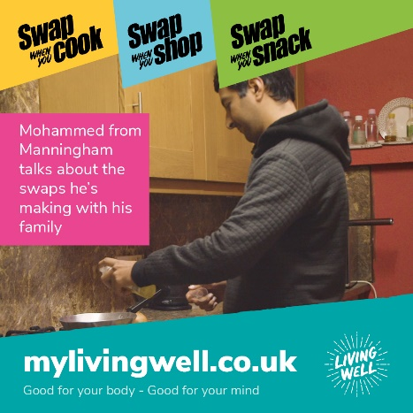
ALT Text | Swap when you cook, swap when you shop, swap when you snack, diagonally across the top of the image. Photo of Mohammed in his kitchen spraying oil in a pan. Pink box with the words; Mohammed from Manningham talks about the swaps he’s making with his family. mylivingwell.co.uk Good for your body – Good for your mind
Twitter | 11-17 March is #NutritionandHydrationWeek  Make your everyday eating habits healthier. Try these 10 easy swaps when you cook, shop and snack!  👀➡️ Watch the film here: https://youtu.be/HNiOdc0EKzM  Find out more here: https://mylivingwell.co.uk/eating-well/swap-well-to-eat-well/  #foodswaps | Swap Well to Eat Well – Twitter 6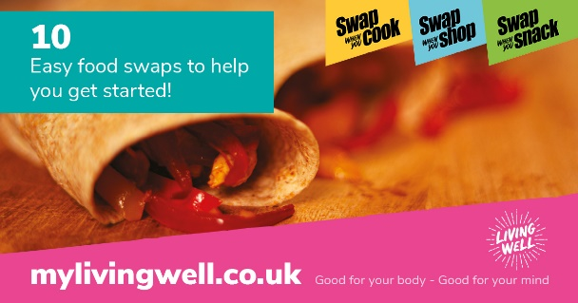
Facebook | 11-17 March is Nutrition and Hydration Week!  Make your everyday eating habits healthier. Try these 10 easy swaps when you cook, shop and snack!  👀➡️ Watch the film here: https://youtu.be/HNiOdc0EKzM  Find out more here: https://mylivingwell.co.uk/eating-well/swap-well-to-eat-well/ | Swap Well to Eat Well – Facebook 6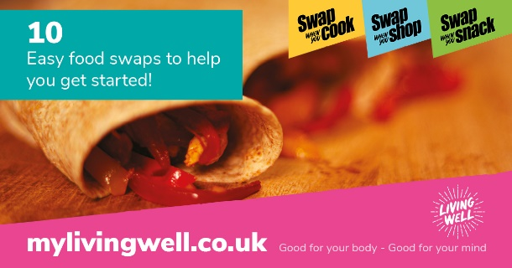
Insta | Make your everyday eating habits healthier. Try these 10 easy swaps when you cook, shop and snack!  👀➡️ Watch the film here: https://youtu.be/HNiOdc0EKzM  www.mylivingwell.co.uk  #NutritionandHydrationWeek #foodswaps #healthyeating #healthyeatinghabits #healthyeatingtips #healthyeatingideas #healthyeatingmadeeasy #healthyeatinglifestyle #healthyswaps #healthyfoodhacks | Swap Well to Eat Well – Instagram 6  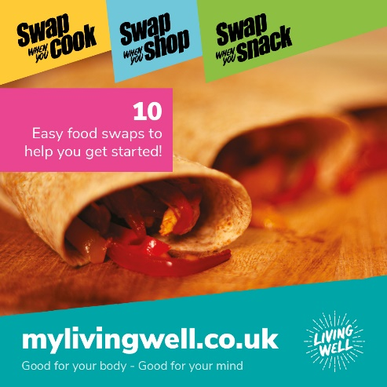
ALT Text | Swap when you cook, swap when you shop, swap when you snack, diagonally across the top of the image. Text reads – 10 easy food swaps to help you get started. Picture of some healthy wraps in the background. mylivingwell.co.uk Good for your body – Good for your mind
Twitter | 11-17 March is #NutritionandHydrationWeek  Stuck for ideas to make lunch boxes tasty AND healthy for you and your family? We can make this easier! Download our info pack online to find out more!  Find out more here: https://mylivingwell.co.uk/eating-well/swap-well-to-eat-well/  #foodswaps | Swap Well to Eat Well – Twitter 7
Facebook | 11-17 March is Nutrition and Hydration Week!  Stuck for ideas to make lunch boxes tasty AND healthy for you and your family? We can make this easier! Download our info pack online to find out more!  Find out more here: https://mylivingwell.co.uk/eating-well/swap-well-to-eat-well/ | Swap Well to Eat Well – Facebook 7
Insta | Stuck for ideas to make lunch boxes tasty AND healthy for you and your family? We can make this easier! Download our info pack online to find out more!  www.mylivingwell.co.uk  #NutritionandHydrationWeek #foodswaps #healthyeating #healthyeatinghabits #healthyeatingtips #healthyeatingideas #healthyeatingmadeeasy #healthyeatinglifestyle #healthyswaps #healthyfoodhacks | Swap Well to Eat Well – Instagram 7  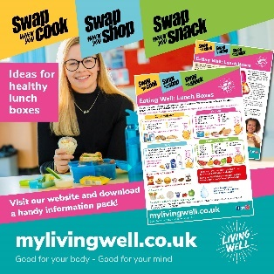
ALT Text | Swap when you cook, swap when you shop, swap when you snack, diagonally across the top of the image. Picture of a woman with a packed lunch box smiling with images of the information pack and inserts on how to make a healthy lunch box. Text reads – Download our handy information from our website mylivingwell.co.uk Good for your body – Good for your mind
Twitter | 11-17 March is #NutritionandHydrationWeek  Get organised with our weekly meal planners. Plan a whole week for all meals & snacks. Includes space for a shopping list so you can stay on track and only buy what you need when food shopping!  Find out more here: https://mylivingwell.co.uk/eating-well/swap-well-to-eat-well/  #foodswaps | Swap Well to Eat Well – Twitter 8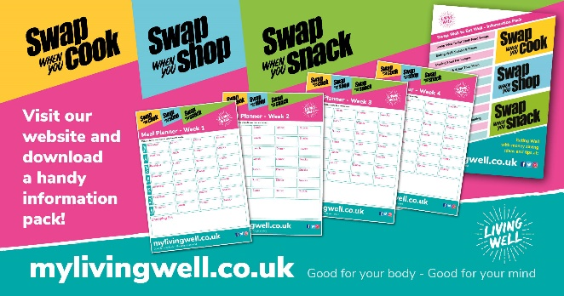
Facebook | 11-17 March is Nutrition and Hydration Week!  Get organised with our weekly meal planners. Plan your whole week including all meals and snacks. Also includes a space for a shopping list so that you can stay on track and only buy what you need to feed you and your family when food shopping  Find out more here: https://mylivingwell.co.uk/eating-well/swap-well-to-eat-well/ | Swap Well to Eat Well – Facebook 8
Insta | Get organised with our weekly meal planners. Plan your whole week including all meals and snacks. Also includes a space for a shopping list so that you can stay on track and only buy what you need to feed you and your family when food shopping  www.mylivingwell.co.uk  #NutritionandHydrationWeek #foodswaps #healthyeating #healthyeatinghabits #healthyeatingtips #healthyeatingideas #healthyeatingmadeeasy #healthyeatinglifestyle #healthyswaps #healthyfoodhacks | Swap Well to Eat Well – Instagram 8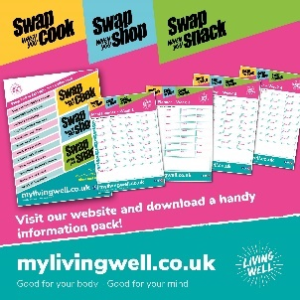
ALT Text | Swap when you cook, swap when you shop, swap when you snack, diagonally across the top of the image. Picture of the information pack with four weekly meal planner inserts. Text reads – Download our handy information from our website mylivingwell.co.uk Good for your body – Good for your mind

If you have any issues or enquiries please contact: communications@mylivingwell.co.uk

