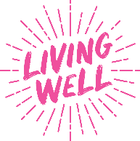
Alcohol Awareness Week - Social Media Planner (1 – 7 July 2024)

Please tag Alcohol Change UK resources: @AlcoholChangeUK
Please tag DrinkCoach resources: @DrinkCoach
Please tag all resources: @MyLivingWell1
(Alcohol Change UK messages link to DrinkCoach (approved by Julie Symes Senior Communications Manager Alcohol Change UK)

Resource from Alcohol Change UK - links to DrinkCoach Alcohol 2 min Test
Message |  | Images available
It’s Alcohol Awareness Week 1-7 July  It’s a chance to think about drinking and understand alcohol harm and the centre-stage role that it plays in our lives.  How much are you drinking? Take the quiz: https://drinkcoach.org.uk/alcohol-test  #AlcoholAwarenessWeek  @AlcoholChangeUK  @MyLivingWell1 |  | 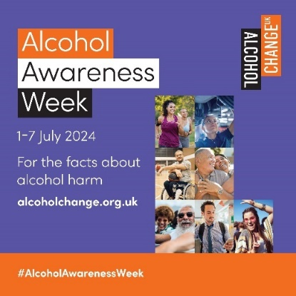  Alcohol Change UK Social Media Images.  Image 1 ACUK Square (jpg) | 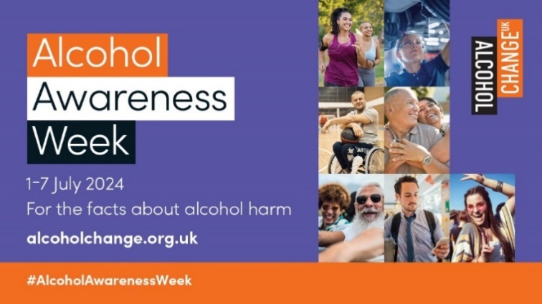  Alcohol Change UK Social Media Images.  Image 1 ACUK Landscape (jpg)
Alt Text | Alcohol Awareness Week 1-7 July 2024. For the facts about alcohol harm visit alcoholchange.org.uk #AlcoholAwarenessWeek
Resource from DrinkCoach - links to DrinkCoach Alcohol 2 min Test
Message |  | Images available
It’s #AlcoholAwarenessWeek and we’re talking about #Units. Men and women are advised to drink no more than 14 units a week with 2-3 days break.  How many units are you drinking? Take the 2-min @DrinkCoach #AlcoholTest to find out https://drinkcoach.org.uk/alcohol-test  @MyLivingWell1 |  | 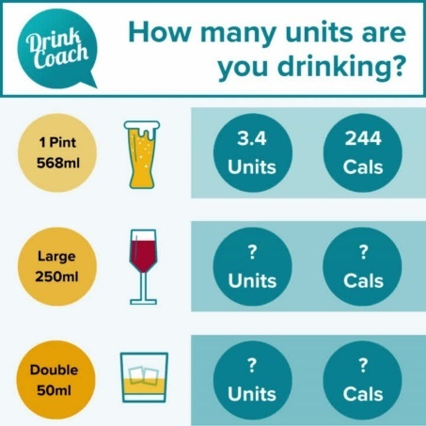DrinkCoach Social Media Images. Animated - DrinkCoach - AAW mixed drinks (mp4) | 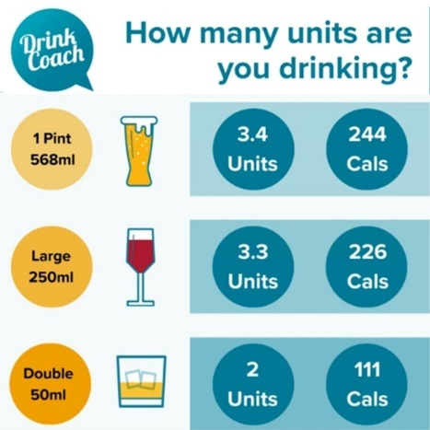  DrinkCoach Social Media Images.  Static - DrinkCoach - AAW mixed drinks (jpg)
Alt Text | How many units are you drinking? Illustration shows 1 pint of beer (568ml) is 3.4 units and 244 calories. Large glass of wine (250ml) is 3.3 units and 226 calories Double shot of spirits (50ml) is 2 units and 111 calories Take the 2-min DrinkCoach Alcohol test: https://drinkcoach.org.uk/alcohol-test
Resource from DrinkCoach - links to DrinkCoach Online Coaching
Message |  | Images available
It’s #AlcoholAwarenessWeek! Know your #Units? Men & women are advised to drink no more than 14 units a week with 2-3 days break. People in #Bradford district can get #Free Online Coaching with an #Alcohol specialist #DrinkLess @DrinkCoach  https://drinkcoach.org.uk/bradford-page  @MyLivingWell1 |  | DrinkCoach Social Media Images. Animated - DrinkCoach - AAW mixed drinks (mp4) | DrinkCoach Social Media Images.  Static - DrinkCoach - AAW mixed drinks (jpg)
Alt Text | How many units are you drinking? Illustration shows 1 pint of beer (568ml) is 3.4 units and 244 calories. Large glass of wine (250ml) is 3.3 units and 226 calories Double shot of spirits (50ml) is 2 units and 111 calories. People in Bradford district can book free online coaching with an alcohol specialist: https://drinkcoach.org.uk/bradford-page
Resource from Alcohol Change UK - links to DrinkCoach Alcohol 2 min Test
Message |  | Images available
Alcohol is all around us. It’s promoted as we watch sport, advertised as we travel to work & shown in films. It’s time for alcohol to take less of a leading role  How much are you drinking? Take the quiz https://drinkcoach.org.uk/alcohol-test  #AlcoholAwarenessWeek  @AlcoholChangeUK  @MyLivingWell1 |  | 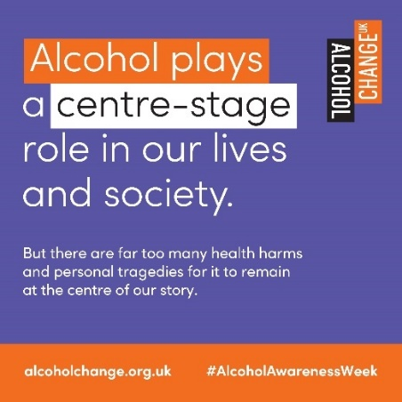  Alcohol Change UK Social Media Images. Image 2 ACUK Square (jpg) | 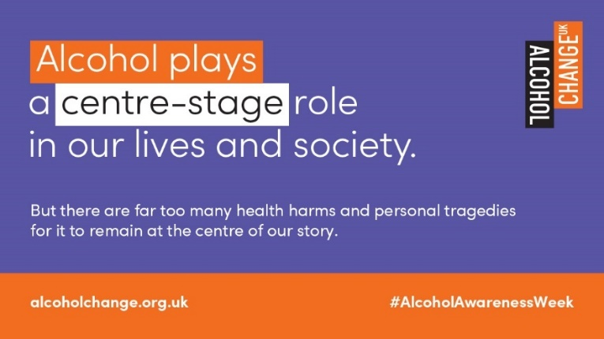  Alcohol Change UK Social Media Images.  Image 2 ACUK Landscape (jpg)
Alt Text | Alcohol plays a centre-stage role in our lives and society. But there are far too many health harms and personal tragedies for it to remain at the centre of the story. alcoholchange.org.uk #AlcoholAwarenessWeek
Resource from DrinkCoach - links to DrinkCoach Alcohol 2 min Test
Message |  | Images available
The higher the #ABV% the higher the #Units. Swap your 9% lager for a 4% beer to save 2.5 units and 210 cals! Make a big difference with small changes.  Take the 2-min @DrinkCoach #AlcoholTest to find out how many #Units you’re drinking. https://drinkcoach.org.uk/alcohol-test  @MyLivingWell1 |  | 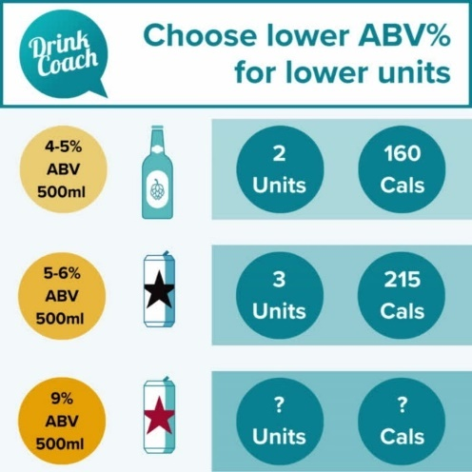  DrinkCoach Social Media Images. Animated - DrinkCoach - AAW beer ABV (mp4) | 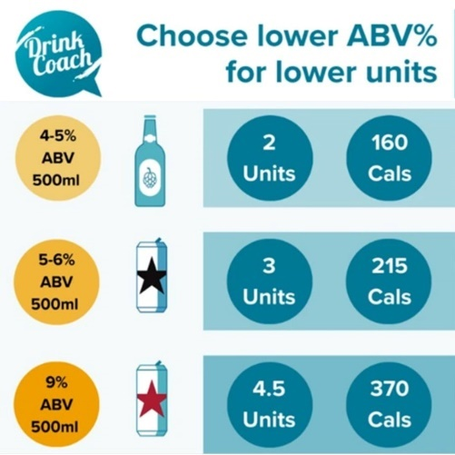  DrinkCoach Social Media Images.  Static - DrinkCoach - AAW beer ABV
Alt Text | Choose lower ABV% for lower units. Illustration shows a bottle of beer 4-5% (500ml) is 2 units and 160 calories. Can of beer 5-6% ABV (500ml) is 3 units and 215 calories. Can of beer 9% ABV (500ml) is 4.5 units and 370 calories. Find out how many units and calories are in your drink https://drinkcoach.org.uk/alcohol-test
Resource from Alcohol Change UK - links to DrinkCoach Alcohol 2 min Test
Message |  | Images available
It's not easy to open up about alcohol use. But knowing more about the harm & how it affects us can help us take better control & improve our health & wellbeing.  How much are you drinking? Take the quiz  https://drinkcoach.org.uk/alcohol-test  #AlcoholAwarenessWeek  @AlcoholChangeUK  @MyLivingWell1 |  | 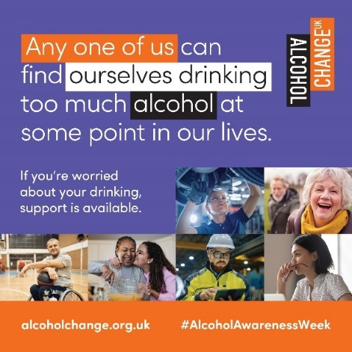  Alcohol Change UK Social Media Images. Image 3 ACUK Square | 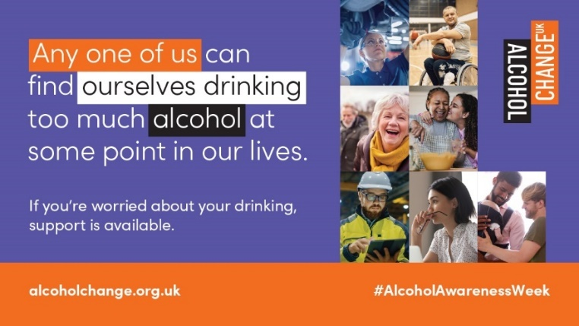  Alcohol Change UK Social Media Images.  Image 3 ACUK Landscape
Alt Text | Any one of us can find ourselves drinking too much alcohol at some point in our lives. If you’re worries about your drinking, support is available. alcoholchange.org.uk #AlcoholAwarenessWeek
Resource from DrinkCoach - links to DrinkCoach Alcohol 2 min Test
Message |  | Images available
Lower the volume to lower #Units. Swap a large wine for a small & save 1.6 units & 113 cals! Make a big difference with small changes. Take the 2-min @DrinkCoach #AlcoholTest to find out how many #Units you’re drinking. #AlcoholAwarenessWeek  https://drinkcoach.org.uk/alcohol-test  @MyLivingWell1 |  | 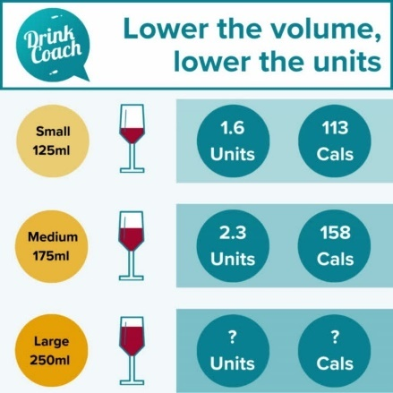  DrinkCoach Social Media Images. Animated - DrinkCoach - AAW wine volume | 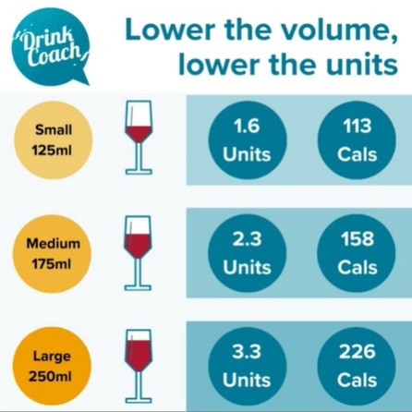  DrinkCoach Social Media Images.  Static - DrinkCoach - AAW wine volume
Alt Text | Lower the volume, lower the units. Illustration shows a small glass of wine (125ml) is 1.6 units and 113 calories. Medium glass of wine (175ml) is 2.3 units and 158 calories. Large glass of wine (250ml) is 3.3 units and 226 calories. Find out how many units and calories are in your drink https://drinkcoach.org.uk/alcohol-test
Resource from Alcohol Change UK - links to DrinkCoach Alcohol 2 min Test
Message |  | Images available
Drinking too much alcohol can leave us with low energy/poor sleep/headaches/hangovers. Cutting back can help us feel better  How much are you drinking? Take the quiz https://drinkcoach.org.uk/alcohol-test  Top tips film https://youtu.be/jpG4PW8eCEY  #AlcoholAwarenessWeek  @AlcoholChangeUK  @MyLivingWell1 |  | 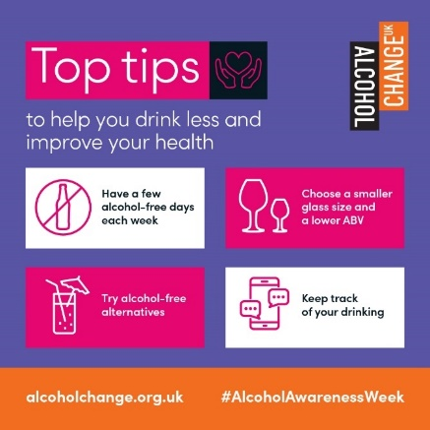  Alcohol Change UK Social Media Images. Image 4 ACUK Square | 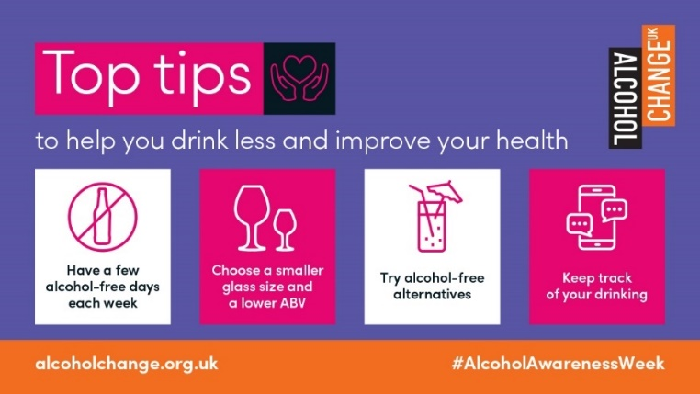  Alcohol Change UK Social Media Images.  Image 4 ACUK Landscape
Alt Text | Top tips to help you drink less and improve your health. Have a few alcohol-free days each week. Choose a smaller glass size and a lover ABV. Tray alcohol-free alternatives. Keep track of your drinking. alcoholchange.org.uk #AlcoholAwarenessWeek
Resource from DrinkCoach - links to DrinkCoach Alcohol 2 min Test
Message |  | Images available
Adults in the UK drink on average 18 units a week, 4 more than advised and an extra 208 units a year! Take the 2-min @DrinkCoach #AlcoholTest to see how many units you’re drinking and changes you might be able to make.  #AlcoholAwarenessWeek  https://drinkcoach.org.uk/alcohol-test  @MyLivingWell1 |  | 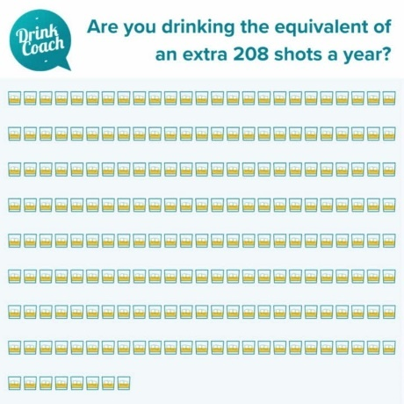  DrinkCoach Social Media Images. Animated - DrinkCoach - AAW 208 shots | DrinkCoach Social Media Images.  Static - DrinkCoach - AAW 208 shots
Alt Text | Are you drinking the equivalent of an extra 208 shots a year? Illustration shows 208 glasses of a spirit.  https://drinkcoach.org.uk/alcohol-test
Resource from Alcohol Change UK - links to DrinkCoach Alcohol 2 min Test
Message |  | Images available
There are many alcohol myths! The truth is it affects more of us than we realise. Cutting down helps us feel better/improve mood/strengthen relationships & more.  How much are you drinking? Take our quiz https://mylivingwell.co.uk/quizzes/  #AlcoholAwarenessWeek  @AlcoholChangeUK  @MyLivingWell1 |  | 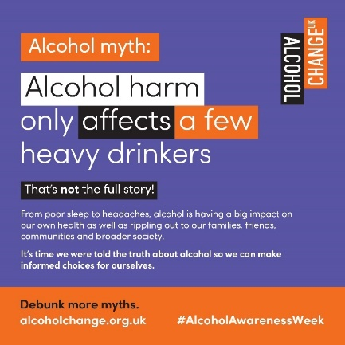  Alcohol Change UK Social Media Images. Image 5 ACUK Square | 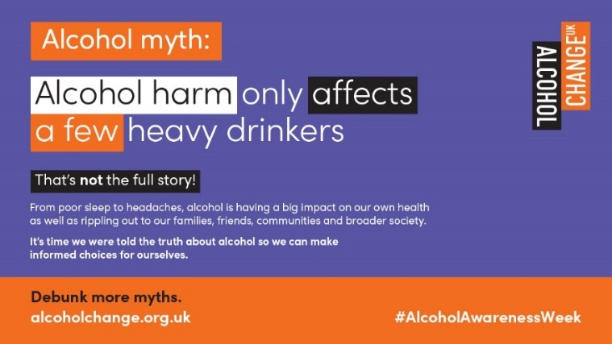  Alcohol Change UK Social Media Images.  Image 5 ACUK Landscape
Alt Text | Alcohol myth: Alcohol harm only affects a few heavy drinkers. That’s not the full story! From poor sleep to headache, alcohol is having a bug impact on our health as well as rippling out to our families, friends, communities and broader society. It’s time we were told the truth about alcohol so we can make informed choices for ourselves. Debunk more myths. alcoholchange.org.uk #AlcoholAwarenessWeek
Resource from DrinkCoach - links to DrinkCoach Alcohol 2 min Test
Message |  | Images available
Do you know your units? 5 large glasses of 13% wine contain 16.5 units but 5 small glasses of 13% wine only have 8. Take the 2-min @DrinkCoach #AlcoholTest see how many units you’re drinking & if it’s within guidelines. #AlcoholAwarenessWeek https://drinkcoach.org.uk/alcohol-test  @MyLivingWell1 |  | 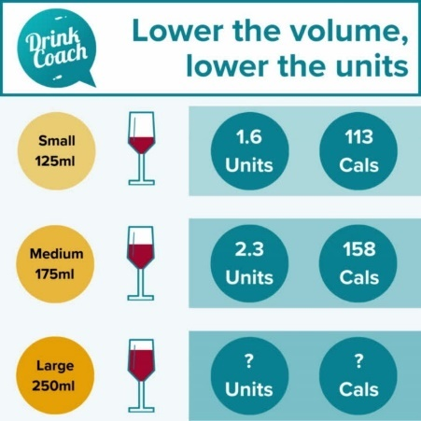  DrinkCoach Social Media Images. Animated - DrinkCoach - AAW wine volume | 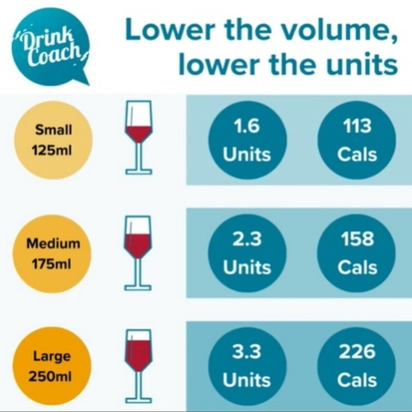  DrinkCoach Social Media Images.  Static - DrinkCoach - AAW wine volume
Alt Text | Lower the volume, lower the units. Illustration shows a small glass of wine (125ml) is 1.6 units and 113 calories. Medium glass of wine (175ml) is 2.3 units and 158 calories. Large glass of wine (250ml) is 3.3 units and 226 calories. Find out how many units and calories are in your drink https://drinkcoach.org.uk/alcohol-test
Resource from Alcohol Change UK - links to DrinkCoach Alcohol 2 min Test
Message |  | Images available
There are so many alcohol myths! The truth is most of us who cut down on alcohol sleep better, lose weight, have more energy and generally feel better.  How much are you drinking? Take the quiz: https://drinkcoach.org.uk/alcohol-test  #AlcoholAwarenessWeek  @AlcoholChangeUK  @MyLivingWell1 |  | 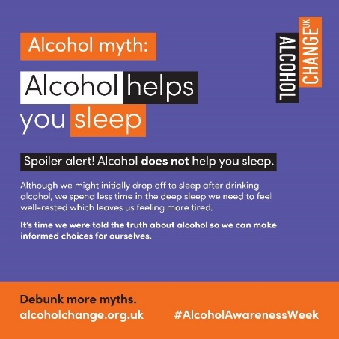  Alcohol Change UK Social Media Images. Image 6 ACUK Square | 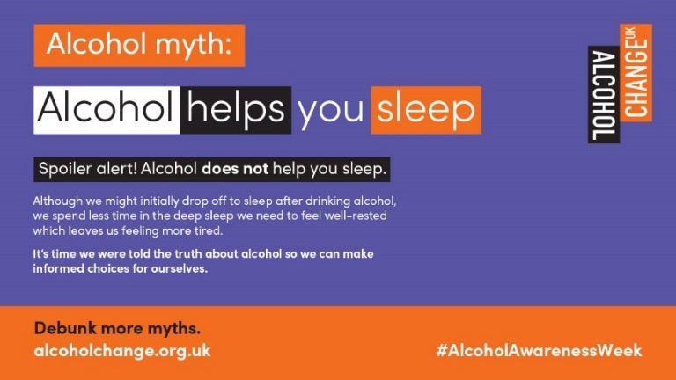  Alcohol Change UK Social Media Images.  Image 6 ACUK Square
Alt Text | Alcohol myth: Alcohol helps you sleep. Spoiler alert! Alcohol does not help you sleep. Although we might initially drop off to sleep after drinking alcohol, we spend less time in the deep sleep we need to feel well rested which leaves us feeling more tired. It’s time we were told the truth about alcohol so we can make informed choices for ourselves. Debunk more myths. alcoholchange.org.uk #AlcoholAwarenessWeek
Resource from DrinkCoach - links to DrinkCoach Online Coaching
Message |  | Images available
Do you know your units? 5 large glasses of 13% wine contain 16.5 units but 5 small glasses of 13% wine only have 8. People in #Bradford district can book #Free Online Coaching with a @drinkcoach specialist. #AlcoholAwarenessWeek  https://drinkcoach.org.uk/bradford-page  @MyLivingWell1 |  | DrinkCoach Social Media Images. Animated - DrinkCoach - AAW wine volume | DrinkCoach Social Media Images.  Static - DrinkCoach - AAW wine volume
Alt Text | Lower the volume, lower the units. Illustration shows a small glass of wine (125ml) is 1.6 units and 113 calories. Medium glass of wine (175ml) is 2.3 units and 158 calories. Large glass of wine (250ml) is 3.3 units and 226 calories. People in Bradford district can book free online coaching with an alcohol specialist: https://drinkcoach.org.uk/bradford-page
Resource from Alcohol Change UK - links to DrinkCoach Alcohol 2 min Test
Message |  | Images available
There are lots of alcohol myths! The truth is you don't need alcohol to have fun/feel happy/or to relax. Lots of us choose not to drink or are cutting down.  How much are you drinking? Take the quiz: https://drinkcoach.org.uk/alcohol-test  #AlcoholAwarenessWeek  @AlcoholChangeUK  @MyLivingWell1 |  | 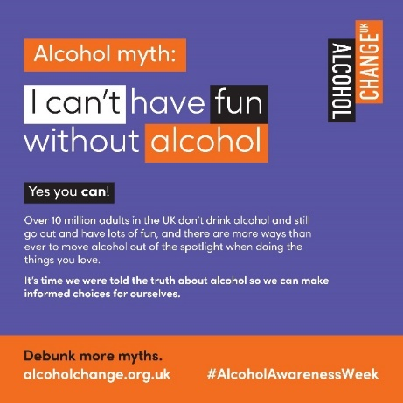  Alcohol Change UK Social Media Images. Image 7 ACUK Square | 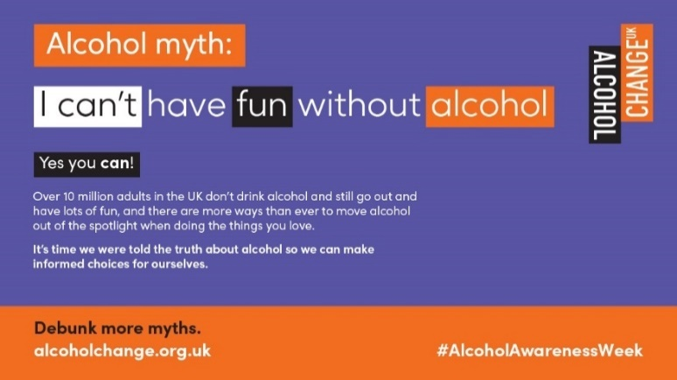  Alcohol Change UK Social Media Images.  Image 7 ACUK Landscape
Alt Text | Alcohol myth: I can’t have fun without alcohol. Yes you can! Over 10 million adults in the UK don’t drink alcohol and still go out and have lots of fun, and there are more ways than ever to move alcohol out of the spotlight when doing the things you love. It’s time we were told the truth about alcohol so we can make informed choices for ourselves. Debunk more myths. alcoholchange.org.uk #AlcoholAwarenessWeek
Resource from DrinkCoach - links to DrinkCoach Online Coaching
Message |  | Images available
Adults in the UK drink on average 18 units a week, 4 more than advised and an extra 208 units a year! Want to lower your units? People in #Bradford district can book #Free Online Coaching with a @drinkcoach specialist. #AlcoholAwarenessWeek  https://drinkcoach.org.uk/bradford-page  @MyLivingWell1 |  | 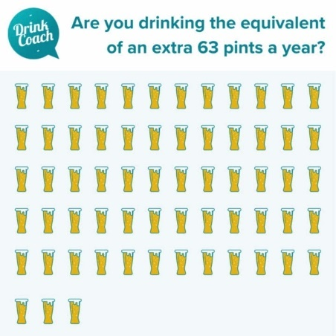  DrinkCoach Social Media Images. Animated - DrinkCoach - AAW 63 Pints | DrinkCoach Social Media Images.  Static - DrinkCoach - AAW 63 Pints
Alt Text | Are you drinking the equivalent of an extra 63 pints a year? Illustration shows 63 pints of beer. People in Bradford district can book free online coaching with an alcohol specialist: https://drinkcoach.org.uk/bradford-page
Resource from Alcohol Change UK - links to DrinkCoach Alcohol 2 min Test
Message |  | Images available
There are so many alcohol myths! The truth is that for anyone who drinks, cutting down on alcohol reduces the risks to our health.  How much are you drinking? Take the quiz: https://drinkcoach.org.uk/alcohol-test  #AlcoholAwarenessWeek  @AlcoholChangeUK  @MyLivingWell1 |  | 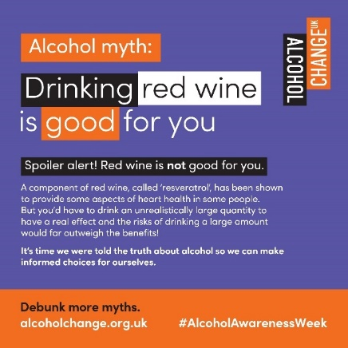  Alcohol Change UK Social Media Images. Image 8 ACUK Square | 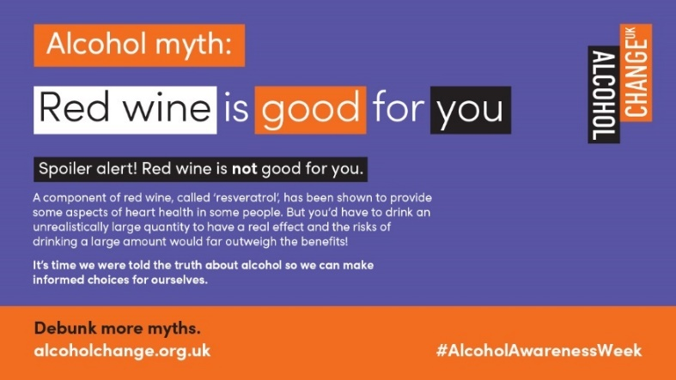  Alcohol Change UK Social Media Images.  Image 8 ACUK Landscape
Alt Text | Alcohol myth: Red wine is good for you. Spoiler alert! Red wine is not good for you. A component of red wine, called ‘reservatrol’ has been shown to provide some aspects of heart health in some people. But you’d have to drink an unrealistically large quantity to have a real affect and the risks of drinking a large amount would far outweigh the benefits! It’s time we were told the truth about alcohol so we can make informed choices for ourselves. Debunk more myths. alcoholchange.org.uk #AlcoholAwarenessWeek

For any queries please email communications@mylivingwell.co.uk

