Stop smoking for Stoptober and you’re five times more likely to quit for good!
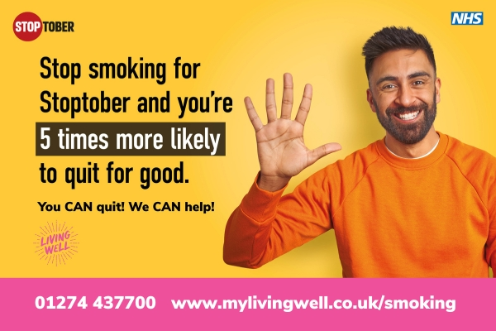
Over 2.5 million people have quit smoking with Stoptober – if you’re a smoker, join thousands of others committing to quit this October.
When you quit smoking for 28 days, you’re five times more likely to quit for good and great things start to happen - you’ll start moving better, breathe more easily and save money.
The Living Well Stop Smoking Service is available for smokers in Bradford district offering free, personal support and professional guidance. Expert advisors will work with you to find the best methods and aids to manage cravings and help you to quit for good. Options include prescribed NRT (nicotine replacement therapy) which may incur prescription charges if you usually pay for them and free 12 week vaping kits.
Over 5 million adults in England still smoke. Smoking causes 64,000 deaths a year, making it the biggest cause of preventable illness and death. Quitting smoking is one of the best things you can do for your health. When you stop there are almost immediate improvements to your health. After just 8 hours harmful carbon monoxide levels in your blood will have reduced by half. After 48 hours your senses of taste and smell are improving. After 2 to 12 weeks your circulation will have improved, and after 3 to 9 months lung function increases by up to 10%.
The average price of a packet of cigarettes is £15.84, which means smokers who buy three to four packets each week could save around £3,000 a year by quitting.
Evidence shows that once people have got past the short-term withdrawal stage of quitting, they have reduced anxiety, depression and stress and increased positive mood compared with people who continue to smoke.
Getting free expert support from your local stop smoking service is proven to give you the best chance of quitting successfully.
Call the Living Well Stop Smoking Service on 01274 437700 or email stopsmokingservice@bradford.gov.uk or visit www.mylivingwell.co.uk/smoking
Stoptober offers a range of free quitting tools including the NHS Quit Smoking app, daily email support, a 28-day email programme, Facebook support group, information about quitting smoking with a vape and expert support from local stop smoking services. Simply search ‘Stoptober’ for more information or visit the Better Health Quit Smoking Website.
- ENDS -
------------------------------------------------------------------------------------------------
Enquiries please contact:
Sacha Reynolds.
Living Well – Communications & Development Officer. Tel: 07582 100502.
Email: Sacha.Reynolds@bradford.gov.uk
Website: www.mylivingwell.co.uk
Social Media: @MyLivingWell1

