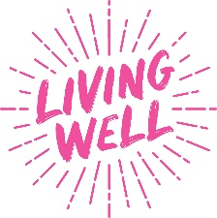
Stoptober 24: Living Well localised social media planner for Bradford district
Please tag @MyLivingWell1 in all posts
STATIC GRAPHICS
Twitter | Image: 220824_OHID_Stoptober_Social_16x9_6
📢 Stoptober starts today!  Join thousands of others & start your quit journey  🚭 Stop smoking for 28 days & you’re 5x more likely to quit for good  You CAN quit! We CAN help!  Contact FREE Living Well Stop Smoking Service 01274 437700  https://mylivingwell.co.uk/smoking/support-to-quit/  #Stoptober #QuitForGood | 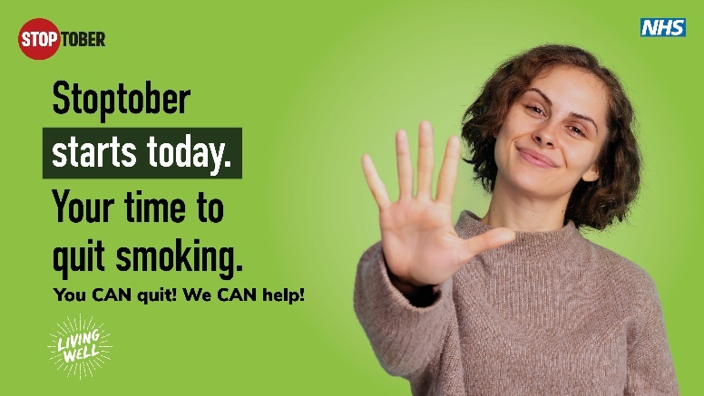
Facebook | Image: 220824_OHID_Stoptober_Social_16x9_6
📢 Stoptober starts today!
Join thousands of others and start your quit journey!
🚭 If you stop smoking for 28 days, you’re 5 times more likely to quit successfully for good!
You CAN quit! We CAN help!
Get FREE support from the Living Well Stop Smoking Service.
Call 01274 437700 or visit:
https://mylivingwell.co.uk/smoking/support-to-quit/
#Stoptober #QuitForGood
Alt Text:
An image of a woman holding her hand up alongside text reading: Stoptober starts today. Your time to quit smoking. You CAN quit! We CAN help! Positioned on a green background with a Stoptober logo, NHS logo and Living Well logo
Instagram | Image: 220824_OHID_Stoptober_Social_1x1_6
📢 #Stoptober starts today!  Join thousands of others and start your quit journey!  🚭 If you stop smoking for 28 days, you’re 5 times more likely to quit successfully for good!  You CAN quit! We CAN help!  Get FREE support from the Living Well Stop Smoking Service.  Call 01274 437700 or visit:  mylivingwell.co.uk/smoking | 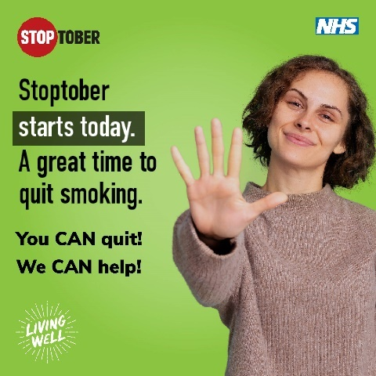
Hashtags:
#Stoptober #QuitForGood #BreakTheHabit #QuitSmokingToday #BreatheEasy #QuitSmokingNow #QuitSmoking #StopSmoking #SmokeFreeLife #Vape #VapeLife #KickTheHabit #QuittingSmoking #HealthierChoices #BreakTheAddiction #StopSmokingNow #NicotineFree #HealthyLiving #NonSmoker
Alt Text:
An image of a woman holding her hand up alongside text reading: Stoptober starts today. A great time to quit smoking. You CAN quit! We CAN help! Positioned on a green background with a Stoptober logo, NHS logo and Living Well logo
Twitter | Image: 220824_OHID_Stoptober_Social_16x9_5
📢 Need help to stop smoking?  🚭 Quitting is the best thing you can do to improve your health.  Quit for 28 days & you’re 5x more likely to quit for good!  You CAN quit! We CAN help!  FREE Living Well Stop Smoking Service 01274 437700  https://mylivingwell.co.uk/smoking/support-to-quit/  #Stoptober #QuitForGood | 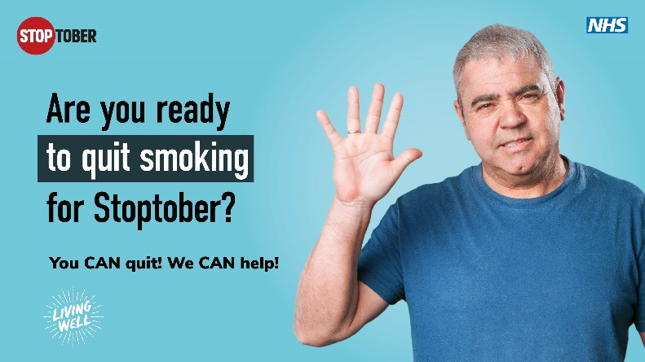
Facebook | Image: 220824_OHID_Stoptober_Social_16x9_5
📢 Would you like help to stop smoking?  🚭 Quitting is the single best thing you can do to improve your health.  Quit for Stoptober and you’re 5x more likely to quit for good!  You CAN quit! We CAN help!  Get FREE support from the Living Well Stop Smoking Service.  Call 01274 437700 or visit:  https://mylivingwell.co.uk/smoking/support-to-quit/  #Stoptober #QuitForGood | 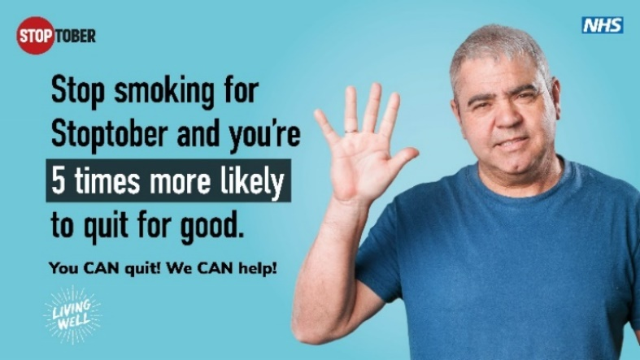
Alt Text:
An image of a man holding his hand up alongside text reading: Stop smoking for Stoptober and you’re 5 times more likely to quit for good. You CAN quit! We CAN help! Positioned on a blue background with a Stoptober logo, NHS logo and Living Well logo
Instagram | Image: 220824_OHID_Stoptober_Social_1x1_5
📢 Would you like help to stop smoking?  🚭 Quitting is the single best thing you can do to improve your health.  Quit for #Stoptober and you’re 5x more likely to quit for good!  You CAN quit! We CAN help!  Get FREE support from the Living Well Stop Smoking Service.  Call 01274 437700 or visit:  mylivingwell.co.uk/smoking | 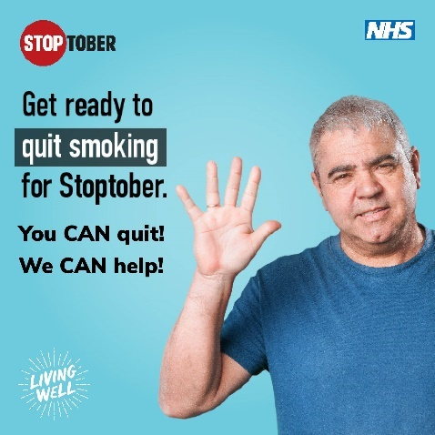
Hashtags:
#Stoptober #QuitForGood #BreakTheHabit #QuitSmokingToday #BreatheEasy #QuitSmokingNow #QuitSmoking #StopSmoking #SmokeFreeLife #Vape #VapeLife #KickTheHabit #QuittingSmoking #HealthierChoices #BreakTheAddiction #StopSmokingNow #NicotineFree #HealthyLiving #NonSmoker
Alt Text:
An image of a man holding his hand up alongside text reading: Get ready to quit smoking for Stoptober. You CAN quit! We CAN help! Positioned on a blue background with a Stoptober logo, NHS logo and Living Well logo
Twitter | Image: 220824_OHID_Stoptober_Social_16x9_3
🚭 Quit smoking for 28 days & you’re 5x more likely to quit for good!  ✅ Move better🚶  ✅ Breathe more easily👃  ✅ Save money💷  You CAN quit! We CAN help!  FREE Living Well Stop Smoking Services can help!  Call 01274 437700 or visit  https://mylivingwell.co.uk/smoking/support-to-quit/  #Stoptober #QuitForGood | 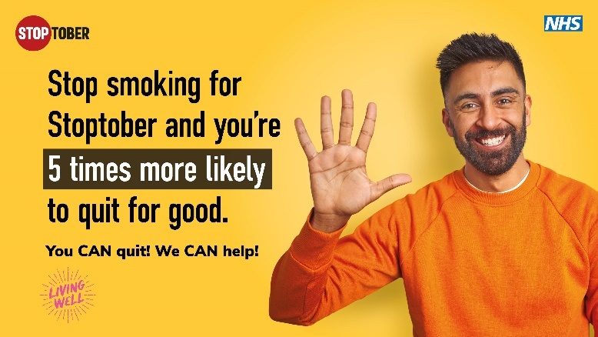
Facebook | Image: 220824_OHID_Stoptober_Social_16x9_3
🚭 Quit smoking for 28 days & you’re 5 times more likely to quit for good!
✅ Move better🚶
✅ Breathe more easily👃
✅ Save money💷
You CAN quit! We CAN help!
Get FREE support from the Living Well Stop Smoking Services
Call: 01274 437700 or visit:
https://mylivingwell.co.uk/smoking/support-to-quit/
#Stoptober #QuitForGood
Alt Text:
An image of a man holding his hand up alongside text reading: Stop smoking for Stoptober and you’re 5 times more likely to quit for good. You CAN quit! We CAN help! Positioned on a yellow background with a Stoptober logo, NHS logo and Living Well logo
Instagram | Image: 220824_OHID_Stoptober_Social_1x1_3
🚭 Quit smoking for 28 days & you’re 5 times more likely to quit for good!  ✅ Move better🚶  ✅ Breathe more easily👃  ✅ Save money💷  You CAN quit! We CAN help!  FREE Living Well Stop Smoking Services can help you.  Call: 01274 437700 or visit:  mylivingwell.co.uk/smoking | 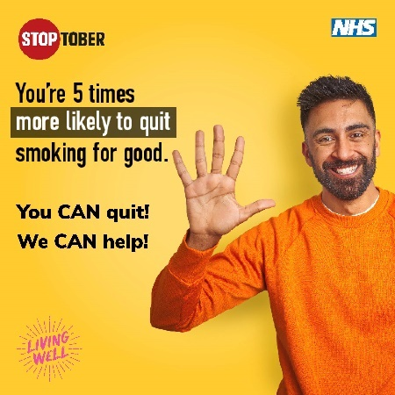
Hashtags:
#Stoptober #QuitForGood #BreakTheHabit #QuitSmokingToday #BreatheEasy #QuitSmokingNow #QuitSmoking #StopSmoking #SmokeFreeLife #Vape #VapeLife #KickTheHabit #QuittingSmoking #HealthierChoices #BreakTheAddiction #StopSmokingNow #NicotineFree #HealthyLiving #NonSmoker
Alt Text:
An image of a man holding his hand up alongside text reading: Stoptober - You’re 5 times more likely to quit smoking for good. You CAN quit! We CAN help! Positioned on a yellow background with a Stoptober logo, NHS logo and Living Well logo
Twitter | Image: 220824_OHID_Stoptober_Social_16x9_4
The average smoker saves about £59 a week when they quit. That’s £3,000 a year! 💷  Quit to make huge improvements to your health AND finances! 🙂  You CAN quit! We CAN help!  FREE Living Well Stop Smoking Services.  Call 01274 437700  https://mylivingwell.co.uk/smoking/support-to-quit/  #Stoptober #QuitForGood | 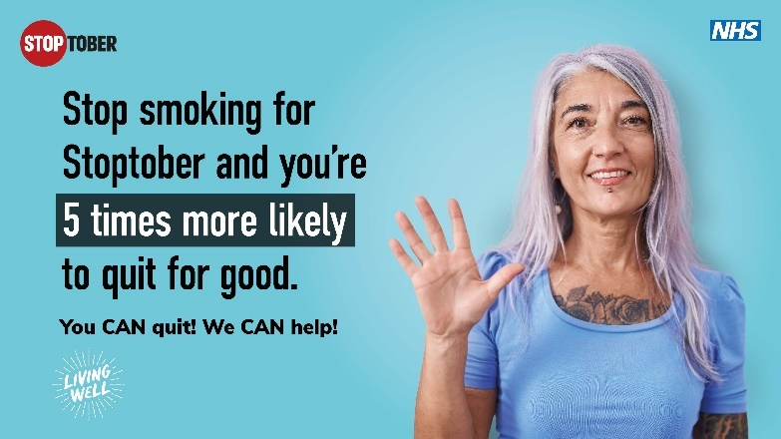
Facebook | Image: 220824_OHID_Stoptober_Social_16x9_4
The average smoker can save about £59 a week by quitting smoking. That’s £3,000 a year! 💷
If you’ve quit for Stoptober you’re not only making huge improvements to your health but also your finances! 🙂
You CAN quit! We CAN help!
FREE Living Well Stop Smoking Services can help you quit for good.
Call: 01274 437700 or visit: https://mylivingwell.co.uk/smoking/support-to-quit/
#Stoptober #QuitForGood
Alt Text:
An image of a woman holding her hand up alongside text reading: Stop smoking for Stoptober and you’re 5 times more likely to quit for good. You CAN quit! We CAN help! Positioned on a blue background with a Stoptober logo, NHS logo and Living Well logo
Instagram | Image: 220824_OHID_Stoptober_Social_1x1_4
The average smoker can save about £59 a week by quitting smoking. That’s £3,000 a year! 💷  If you’ve quit for #Stoptober you’re not only making huge improvements to your health but also your finances! 🙂  You CAN quit! We CAN help!  FREE Living Well Stop Smoking Services can help you quit for good.  Call: 01274 437700 or visit:  mylivingwell.co.uk/smoking | 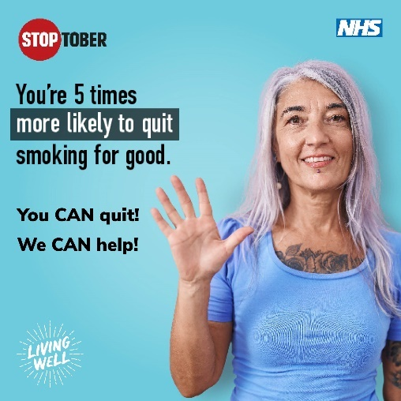
Hashtags:
#Stoptober #QuitForGood #BreakTheHabit #QuitSmokingToday #BreatheEasy #QuitSmokingNow #QuitSmoking #StopSmoking #SmokeFreeLife #Vape #VapeLife #KickTheHabit #QuittingSmoking #HealthierChoices #BreakTheAddiction #StopSmokingNow #NicotineFree #HealthyLiving #NonSmoker
Alt Text:
An image of a woman holding her hand up alongside text reading: Stoptober - You’re 5 times more likely to quit smoking for good. You CAN quit! We CAN help! Positioned on a blue background with a Stoptober logo, NHS logo and Living Well logo
Twitter | Image: 220824_OHID_Stoptober_Social_16x9_1
Thinking of using a vape to quit smoking? Nicotine vaping is substantially less harmful than smoking & is one of the most effective tools for quitting  #Bradford district smokers: get a FREE 12 week vape kit! Call 01274 437700  Visit https://mylivingwell.co.uk/smoking/support-to-quit/  #Stoptober #QuitForGood | 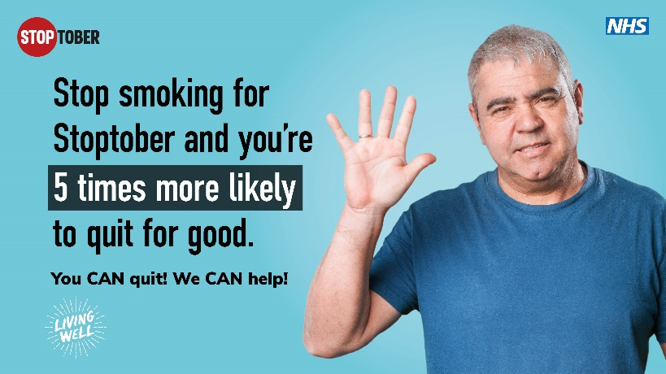
Facebook | Image: 220824_OHID_Stoptober_Social_16x9_1
Thinking of using a vape to quit smoking?
Nicotine vaping is substantially less harmful than smoking and is one of the most effective tools for quitting smoking.
Bradford district residents can get a FREE 12 week vape kit when they use the FREE Living Well Stop Smoking Service.
You CAN quit! We CAN help!
Call: 01274 437700
Visit: https://mylivingwell.co.uk/smoking/support-to-quit/
#Stoptober #QuitForGood
Alt Text:
An image of a man holding his hand up alongside text reading: Stop smoking for Stoptober and you’re 5 times more likely to quit for good. You CAN quit! We CAN help! Positioned on a blue background with a Stoptober logo, NHS logo and Living Well logo
Instagram | Image: 220824_OHID_Stoptober_Social_1x1_1
Thinking of using a vape to quit smoking?  Nicotine vaping is substantially less harmful than smoking and is one of the most effective tools for quitting smoking.  Bradford district residents can get a FREE 12 week vape kit when they use the FREE Living Well Stop Smoking Service.  You CAN quit! We CAN help!  Call: 01274 437700 or visit:  mylivingwell.co.uk/smoking | 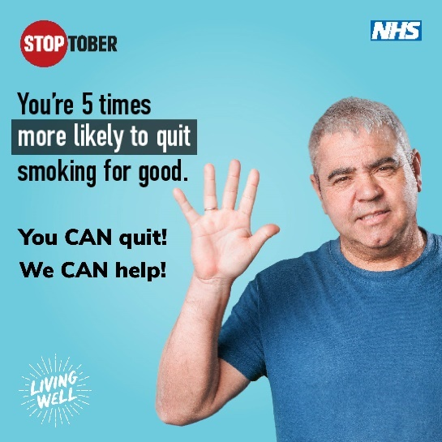
Alt Text:
An image of a man holding his hand up alongside text reading: Stoptober - You’re 5 times more likely to quit smoking for good. You CAN quit! We CAN help! Positioned on a blue background with a Stoptober logo, NHS logo and Living Well logo
Hashtags:
#Stoptober #QuitForGood #BreakTheHabit #QuitSmokingToday #BreatheEasy #QuitSmokingNow #QuitSmoking #StopSmoking #SmokeFreeLife #Vape #VapeLife #KickTheHabit #QuittingSmoking #HealthierChoices #BreakTheAddiction #StopSmokingNow #NicotineFree #HealthyLiving #NonSmoker
ANIMATED GRAPHICS
Twitter | Animation: Stoptober_animated_social_1x1_Tips
If you have quit smoking for Stoptober here are some tips to help you on your quitting journey.  You CAN quit! We CAN help!  🚭 Get FREE support from Living Well Stop Smoking Services.  Call: 01274 437700  Visit: https://mylivingwell.co.uk/smoking/support-to-quit/  #Stoptober #QuitForGood | 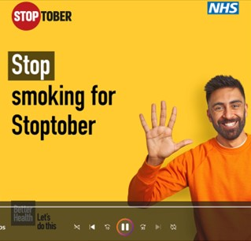
Facebook | Animation: Stoptober_animated_social_1x1_Tips
If you have quit smoking for Stoptober here are some tips to help you stay on your quitting journey.
Quitting smoking is easier with support – you don’t need to go it alone!
You CAN quit! We CAN help!
🚭 Get FREE support from Living Well Stop Smoking Services.
Call: 01274 437700
Visit: https://mylivingwell.co.uk/smoking/support-to-quit/
#Stoptober #QuitForGood
Instagram | Animation: Stoptober_animated_social_1x1_Tips
If you have quit smoking for Stoptober here are some tips to help you stay on your quitting journey.
Quitting smoking is easier with support – you don’t need to go it alone!
You CAN quit! We CAN help!
🚭 Get FREE support from Living Well Stop Smoking Services.
Call: 01274 437700 or visit:
mylivingwell.co.uk/smoking
#Stoptober #QuitForGood
Hashtags:
#Stoptober #QuitForGood #BreakTheHabit #QuitSmokingToday #BreatheEasy #QuitSmokingNow #QuitSmoking #StopSmoking #SmokeFreeLife #Vape #VapeLife #KickTheHabit #QuittingSmoking #HealthierChoices #BreakTheAddiction #StopSmokingNow #NicotineFree #HealthyLiving #NonSmoker
Twitter | Animation: Stoptober_animated_social_1x1_Benefits
If you quit smoking your longer-term risks of cancer/lung disease/heart disease/stroke will significantly reduce. More oxygen will get to your skin making it brighter & your teeth won't be stained with tar.  Get FREE support:  https://mylivingwell.co.uk/smoking/support-to-quit/  #Stoptober #QuitForGood | 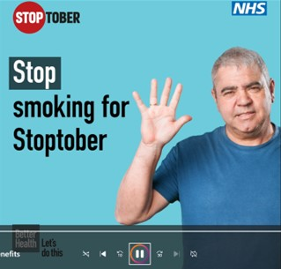
Facebook | Animation: Stoptober_animated_social_1x1_Benefits
If you’ve quit smoking for Stoptober, your longer-term risks of cancer, lung disease, heart disease & stroke will significantly reduce. More oxygen will be getting to your skin making it brighter & your teeth will no longer be getting stained with tar.
You CAN quit! We CAN help!
🚭 Get FREE support from Living Well Stop Smoking Services.
Call: 01274 437700
Visit: https://mylivingwell.co.uk/smoking/support-to-quit/
#Stoptober #QuitForGood
Instagram | Animation: Stoptober_animated_social_1x1_Benefits
If you’ve quit smoking for Stoptober, your longer-term risks of cancer, lung disease, heart disease & stroke will significantly reduce. More oxygen will be getting to your skin making it brighter & your teeth will no longer be getting stained with tar.
FREE Living Well Stop Smoking Services.
Call: 01274 437700 or visit:
mylivingwell.co.uk/smoking
Hashtags:
#Stoptober #QuitForGood #BreakTheHabit #QuitSmokingToday #BreatheEasy #QuitSmokingNow #QuitSmoking #StopSmoking #SmokeFreeLife #Vape #VapeLife #KickTheHabit #QuittingSmoking #HealthierChoices #BreakTheAddiction #StopSmokingNow #NicotineFree #HealthyLiving #NonSmoker
Twitter | Animation: Stoptober_animated_social_1x1_Support
Quitting smoking is easier with support – you don’t need to go it alone!  Get help from your local Living Well Stop Smoking Service.  It’s FREE for people who live in #Bradford district.  You CAN quit – We CAN help!  Call: 01274 437700  https://mylivingwell.co.uk/smoking/support-to-quit/  #Stoptober #QuitForGood | 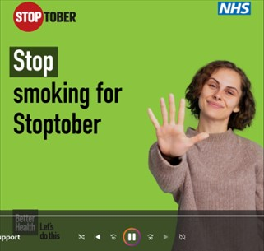
Facebook | Animation: Stoptober_animated_social_1x1_Support
Quitting smoking is easier with support – you don’t need to go it alone!
Get help from your local Living Well Stop Smoking Service.
It’s FREE for people who live in #Bradford district.
You CAN quit! We CAN help!
🚭 Get FREE support from Living Well Stop Smoking Services.
Call: 01274 437700
Visit: https://mylivingwell.co.uk/smoking/support-to-quit/
#Stoptober #QuitForGood
Instagram | Animation: Stoptober_animated_social_1x1_Support
Quitting smoking is easier with support – you don’t need to go it alone!
Get help from your local Living Well Stop Smoking Service.
It’s FREE for people who live in #Bradford district.
You CAN quit – We CAN help!
Call: 01274 437700 or visit:
mylivingwell.co.uk/smoking
Hashtags:
#Stoptober #QuitForGood #BreakTheHabit #QuitSmokingToday #BreatheEasy #QuitSmokingNow #QuitSmoking #StopSmoking #SmokeFreeLife #Vape #VapeLife #KickTheHabit #QuittingSmoking #HealthierChoices #BreakTheAddiction #StopSmokingNow #NicotineFree #HealthyLiving #NonSmoker

