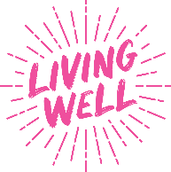
Social Media Planner: Stronger for Longer
Please tag @MyLivingWell1
If you have any issues or enquiries or need the graphics to be sent via WeTransfer please contact: communications@mylivingwell.co.uk
Platform | Message | Image
X (Twitter) | Staying strong helps us stay active, confident & independent as we age. From our 40s we start to lose muscle, but it’s never too late to build strength. Small steps now can make a big difference later. Try these simple exercises:  https://mylivingwell.co.uk/stronger-for-longer-exercises/  #20MinMove  @MyLivingWell1 | 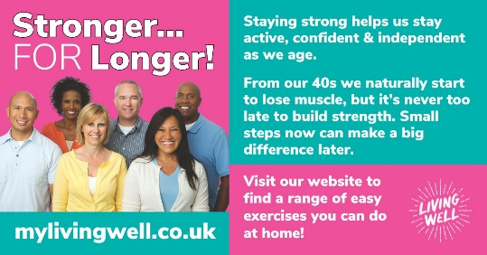  Or film: https://youtu.be/M54zG9Ydh5E
Facebook | Staying strong helps us stay active, confident and independent as we age. From our 40s onwards, we naturally start to lose muscle, but the good news? its never too late to build strength. Small steps now can make a big difference later. Ready to feel stronger? Check out these simple exercises designed for you!  https://mylivingwell.co.uk/stronger-for-longer-exercises/  #20MinMove  @MyLivingWell1 | Or film: https://youtu.be/M54zG9Ydh5E
Instagram | Staying strong helps us stay active, confident and independent as we age. From our 40s onwards, we naturally start to lose muscle, but the good news? its never too late to build strength. Small steps now can make a big difference later. Ready to feel stronger? Check out these simple exercises designed for you!  mylivingwell.co.uk  #20MinMove #Exercise #Over40 #FitForLife #HealthyLifestlye #StayStrong #Wellbeing  @MyLivingWell1 | 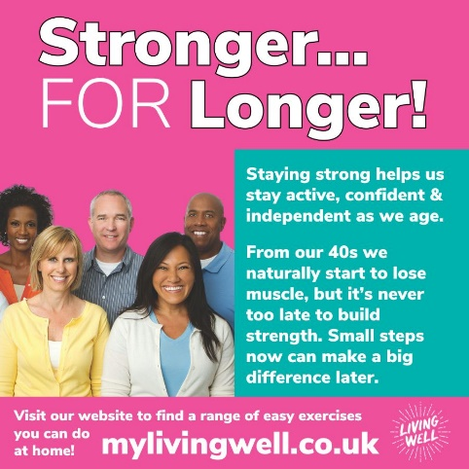  Or film: https://youtu.be/M54zG9Ydh5E
Alt Text | Pink background. White text reads: Stronger for Longer! Below is a photo of a group of people over the age of 40 smiling into the camera. To the right is a teal coloured box with white text that reads: Staying strong helps us stay active, confident & independent as we age. From our 40s we naturally start to lose muscle, but it’s never too late to build strength. Small steps now can make a big difference later. Visit our website to find a range of easy exercises you can do at home! Mylivingwell.co.uk and the Living Well logo.
X (Twitter) | Building strength in your 40s helps you stay active, independent & feeling your best. It can support your body through menopause, improve wellbeing & protect your bones in later life. Try these simple exercises to get started. https://mylivingwell.co.uk/stronger-for-longer-exercises/  #20MinMove  @MyLivingWell1 | 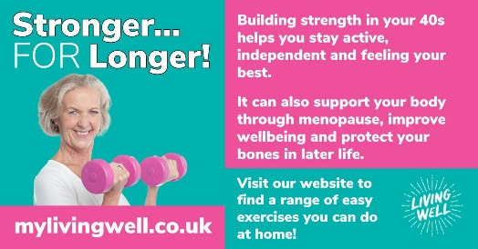
Facebook | Building strength in your 40s helps you stay active, independent and feeling your best. It can also support your body through menopause, improve wellbeing and protect your bones in later life. Visit the My Living Well website for simple exercises to get you started. https://mylivingwell.co.uk/stronger-for-longer-exercises/  #20MinMove  @MyLivingWell1
Instagram | Building strength in your 40s helps you stay active, independent and feeling your best. It can also support your body through menopause, improve wellbeing and protect your bones in later life. Visit the My Living Well website for simple exercises to get you started:  mylivingwell.co.uk  #20MinMove #Exercise #Over40 #FitForLife #HealthyLifestlye #StayStrong #Menopause #BoneStrength #Wellbeing  @MyLivingWell1 | 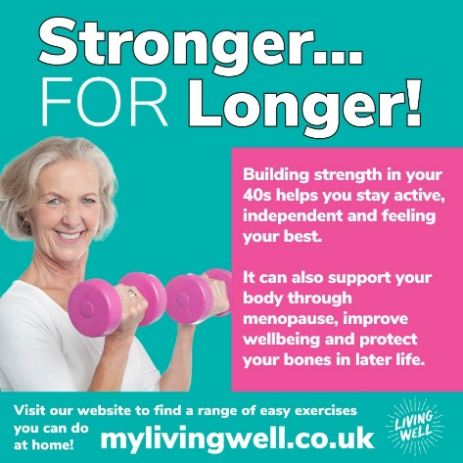
Alt Text: | Teal background. White text reads: Stronger for Longer! Below is a photo of a women over the age of 40 smiling into the camera and holding two pink weights. To the right is a pink coloured box with white text that reads: Building strength in your 40s helps you stay active, independent and feeling your best. It can also support your body through menopause, improve wellbeing and protect your bones in later life. Visit our website to find a range of easy exercises you can do at home! Mylivingwell.co.uk and the Living Well logo.
X (Twitter) | Staying strong does more than build muscle, it can boost your mood, improve sleep, support a healthy weight and increase confidence. Start small – click the link for simple exercises you can do at home!  https://mylivingwell.co.uk/stronger-for-longer-exercises/  #20MinMove  @MyLivingWell1 | 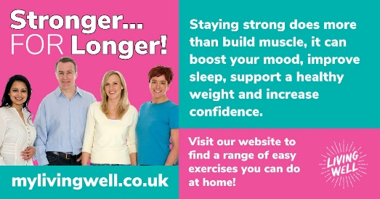
Facebook | Staying strong does more than build muscle, it can boost your mood, improve sleep, support a healthy weight and increase confidence. Start small – click the link for simple exercises you can do at home!  https://mylivingwell.co.uk/stronger-for-longer-exercises/  #20MinMove  @MyLivingWell1
Instagram | Staying strong does more than build muscle, it can boost your mood, improve sleep, support a healthy weight and increase confidence. Start small – click the link for simple exercises you can do at home!  mylivingwell.co.uk  #20MinMove #Exercise #Over40 #FitForLife #HealthyLifestlye #StayStrong #Wellbeing  @MyLivingWell1 | 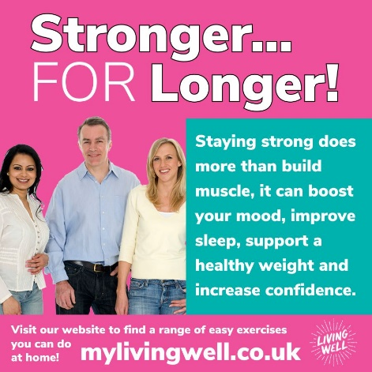
Alt Text | Pink background. White text reads: Stronger for Longer! Below is a photo of a group of people over the age of 40 smiling into the camera. To the right is a teal coloured box with white text that reads: Staying strong does more than build muscle, it can boost your mood, improve sleep, support a healthy weight and increase confidence. Visit our website to find a range of easy exercises you can do at home! Mylivingwell.co.uk and the Living Well logo.
X (Twitter) | Strengthening activities can help manage health conditions & lower the risk of others. In our 40s, muscles loss begins, but it’s never too late to build strength & take control of your health. Try some easy exercises today!  https://mylivingwell.co.uk/stronger-for-longer-exercises/  #20MinMove  @MyLivingWell1 | 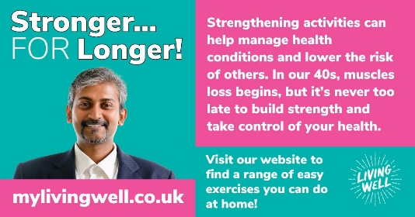
Facebook | Strengthening activities can help manage health conditions and lower the risk of others. In our 40s, muscles loss begins, but it’s never too late to build strength and take control of your health. Get started with these easy, at home exercises today! https://mylivingwell.co.uk/stronger-for-longer-exercises/  #20MinMove  @MyLivingWell1
Instagram | Strengthening activities can help manage health conditions and lower the risk of others. In our 40s, muscles loss begins, but it’s never too late to build strength and take control of your health. Get started with these easy, at home exercises today!  mylivingwell.co.uk  #20MinMove #Exercise #Over40 #FitForLife #HealthyLifestlye #StayStrong #Wellbeing #LongTermConditions  @MyLivingWell1 | 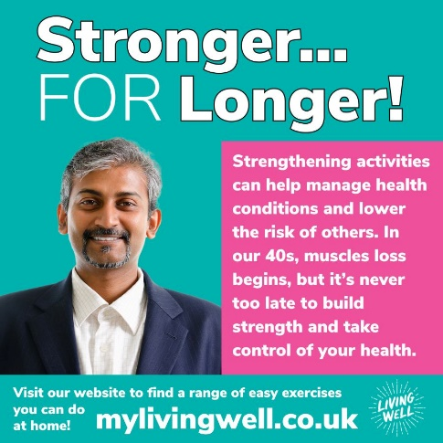
ALT Text | Teal background. White text reads: Stronger for Longer! Below is a photo of a man over the age of 40 smiling into the camera. To the right is a pink coloured box with white text that reads: Strengthening activities can help manage health conditions and lower the risk of others. In our 40s, muscles loss begins, but it’s never too late to build strength and take control of your health. Visit our website to find a range of easy exercises you can do at home! Mylivingwell.co.uk and the Living Well logo.

