Stronger for Longer - With Living Well
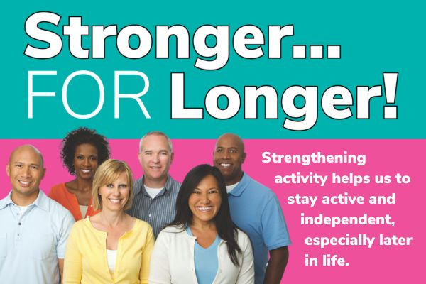
As we get older, our bodies naturally go through some changes. From the age of 40, we start losing muscle mass, which can affect how we move and function in everyday life. But don’t worry, it’s not all downhill from here, strengthening activities are key to keeping us feeling strong, active, and independent for years to come.
Why is it important?
Strengthening activities do more than just build muscle! they can improve your mood, help maintain a healthy weight, improve sleep, and boost your overall wellbeing. And if you’re managing a health condition, they can also help reduce risks and keep you feeling in control of your body.
Who should be doing this?
Strengthening exercises are for everyone, but especially important for those of us over 40. Muscle loss is a natural part of aging, but it’s never too late to start supporting our bodies. These exercises can help manage changes in your body, improve bone health, and even support with menopause symptoms.
How can I get started?
The good news is it doesn’t have to be complicated! You can easily add strengthening activities into your daily routine at home, outdoors, or even through structured exercise. Try to aim for at least two strengthening sessions per week.
Let’s get strong together!
Even small steps make a huge difference. Your body will thank you for it, and you’ll notice the benefits!
Living Well has made it easy for you visit https://mylivingwell.co.uk/stronger-for-longer-exercises/ to find some simple exercises you can do at home, with step-by-step instructions.
For those who prefer a physical copy, booklets will be available in Bradford district libraries soon, and you can also pick up a copy from the Living Well team at community events.
If you would some copies for a community group or a service please e-mail: hello@mylivingwell.co.uk with your request.

