Join the 20 Minute Movement and get moving this summer!
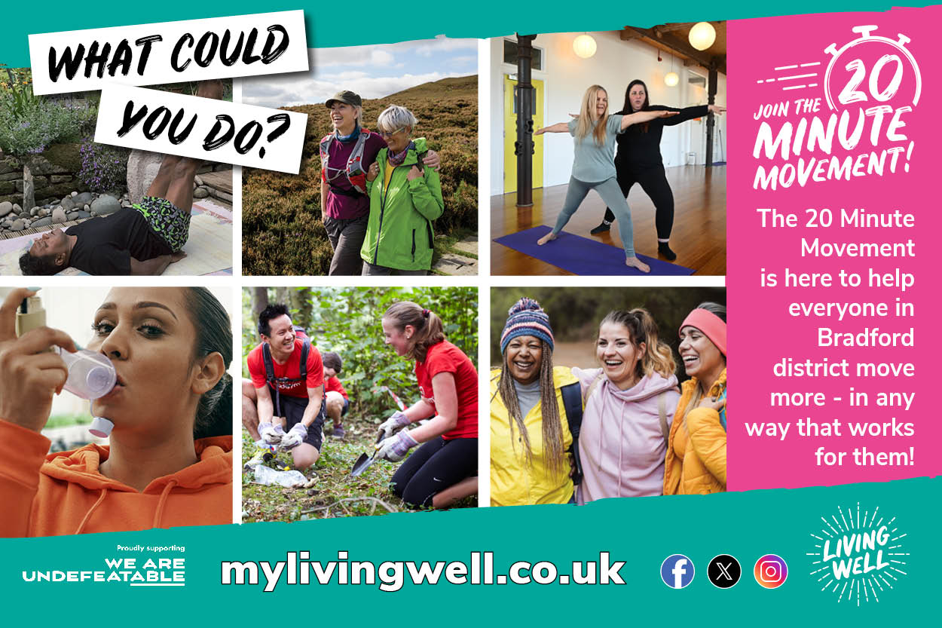
The 20 Minute Movement is helping people across Bradford district get more active in ways that work for them - no gym required!
Whether you're managing a long-term health condition, looking for community-based activities, or just need a little motivation, there’s something for everyone.
Ways to Get Involved:
- Volunteer and Move: Join GoodGym a community of people who get fit by doing good! You can walk, run, or cycle while helping your community.
Read about some of the fantastic already work carried out by Bradford Goodgymers https://www.goodgym.org/v3/areas/bradford/reports

Find out more about GoodGym https://mylivingwell.co.uk/news-post/goodgym-is-coming-to-bradford/
- Health Conditions: We Are Undefeatable and the Living Well BEEP service offer support and tailored activities for people with long-term conditions.
Find out more about Undefeatables (Link to new section in 20MM campaign page that will link to https://weareundefeatable.co.uk/)
Find out more about BEEP https://mylivingwell.co.uk/physical-activity/beep-bradford-encouraging-exercise-in-people/
- Walking Groups: The Well Together Service runs free, friendly walks led by trained volunteers.
Find out more about the benefits of walking https://mylivingwell.co.uk/walking/
Find out more about the Well Together Service https://www.bdct.nhs.uk/our-services/mental-health-services/well-together-service/
Stay Stronger for Longer: Strengthening activities help maintain independence and boost wellbeing as we age.
Watch our short film about the benefits of staying Stronger For Longer https://youtu.be/M54zG9Ydh5E
To help you get started, we’ve created some simple exercises you can do at home, with step-by-step instructions https://mylivingwell.co.uk/20-minute-movement/stronger-for-longer/
Real Stories:
Ellen boosted her daily steps by combining walking with litter picking, while Frances regained her fitness and confidence through the free Living Well offer that gives people 12 weeks free membership to weight management groups and joined local classes.
Read Ellen’s story: https://mylivingwell.co.uk/news-post/ellen-dempsey-has-joined-the-20-minute-movement/
Read France’s story: https://mylivingwell.co.uk/news-post/frances-has-joined-the-20-minute-movement/
No matter your starting point, the 20 Minute Movement is here to help you take that first step - your way.
Join the 20 Minute Movement https://mylivingwell.co.uk/20-minute-movement/

