
Social Media Planner: 20Minute Movement Campaign - August 2025 onwards
Messages to promote physical activity options for adults in Bradford district.
- Long term conditions: Messages linked to #Undefeatables case studies.
- Active in the community: Messages linked to GoodGym volunteering options
- Walking: Messages linked to Well Together Walks for all including people with long term conditions.
- Stronger for Longer: Exercises for those who would like to increase their physical activity in a home environment.
Please tag @MyLivingWell1 and use #20MinMove
All campaign resources are available to download from: https://mylivingwell.co.uk/resources/toolkits/
If you have any issues, enquiries please contact: communications@mylivingwell.co.uk

Platform | Event Messages | Images
X (Twitter) | #20MinMove is here to help people in #Bradford district move more - any way that works for them!  ✅ Long-term health conditions  ✅ Getting active without a gym  ✅ Active community volunteering  ✅ Ideas to get started  https://mylivingwell.co.uk/20-minute-movement/  @MyLivingWell1 #WeAreUndefeatable | 20MM Social Media Landscape 1.jpg  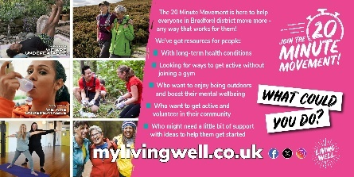
Facebook | 🏃🚶💃🕺🏋️🧘🤸🏊🚴The 20 Minute Movement is here to help people in #Bradford district to move more - any way that works for them! We’ve got resources for people:  ✅ With long-term health conditions  ✅ Who are looking for ways to get active that don’t involve joining a gym  ✅ Who want to get active and volunteer in their community  ✅ Who just need a little bit of support to get started  Visit us to find out more: https://mylivingwell.co.uk/20-minute-movement/  #20MinMove #WeAreUndefeatable @MyLivingWell1 | 20MM Social Media Landscape 1.jpg
Instagram | 🏃🚶💃🕺🏋️🧘🤸🏊🚴The 20 Minute Movement is here to help people in #Bradford district to move more - any way that works for them! We’ve got resources for people:  ✅ With long-term health conditions  ✅ Who are looking for ways to get active that don’t involve joining a gym  ✅ Who want to get active and volunteer in their community  ✅ Who just need a little bit of support to get started  Visit us to find out more: mylivingwell.co.uk  @MyLivingWell1 #WeAreUndefeatable #chronicconditions #betterhealth #HealthAndMovement #ActiveWithConditions #FitnessForHealth #YogaForHealth #MoveWithPurpose #HealthyActiveLifestyle #WalkingWithConditions #MoveMore #FitnessForAll #GetFitTogether #CommunityHealth #VolunteerFitness #ActiveCommunity #HealthyHabits #FitForGood #ExerciseTogether #20MinMove | 20MM Social Media Square 1.jpg  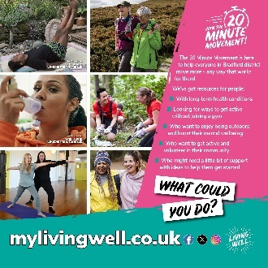
Alt Text | Photo montage showing a man lying on his back doing yoga, two women walking outside on the moors, a woman taking asthma medication using an inhaler, two happy people gardening, two women standing doing yoga poses and two women smiling while out walking. At the top right-hand side on a pink background the 20 Minute Movement logo with text that reads: The 20 Minute Movement is here to help everyone in Bradford district move more - any way that works for them! We’ve got resources for people: With long-term health conditions / Looking for ways to get active that don’t involve joining a gym / Who want to get active and volunteer in their community / Who just need a little bit of support to get started. Visit us to find out more. White rectangles at an angle with black text reads: WHAT COULD YOU DO? Across the bottom of the image: mylivingwell.co.uk social media logos and the Living Well logo
X (Twitter) | 🏃🚶💃🏋️🧘🤸🏊🚴Dancing while washing up or practicing keepy-uppies - it all adds up! Living with a health condition can also make it challenging. It’s ok if you’re not up to it today - tomorrow is another day. https://mylivingwell.co.uk/20-minute-movement/  #20MinMove #WeAreUndefeatable @MyLivingWell1 | 20MM Social Media Landscape 2.jpg  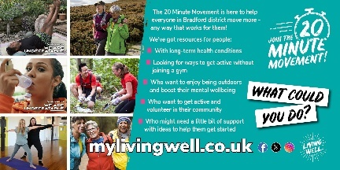
Facebook | 🏃🚶💃🕺🏋️🧘🤸🏊🚴Whether you’re dancing whilst doing the washing up or practicing keepy-uppies, it all adds up. Living with a health condition can also make getting active challenging. It’s ok if you’re not up to it today - tomorrow is another day. Find inspiration for ways to move more: https://mylivingwell.co.uk/20-minute-movement/  #20MinMove #WeAreUndefeatable @MyLivingWell1 | 20MM Social Media Landscape 2.jpg
Instagram | 🏃🚶💃🕺🏋️🧘🤸🏊🚴Whether you’re dancing whilst doing the washing up or practicing keepy-uppies, it all adds up. Living with a health condition can also make getting active challenging. It’s ok if you’re not up to it today - tomorrow is another day. Find inspiration for ways to move more: mylivingwell.co.uk  @MyLivingWell1 #WeAreUndefeatable #chronicconditions #betterhealth #HealthAndMovement #ActiveWithConditions #FitnessForHealth #YogaForHealth #MoveWithPurpose #HealthyActiveLifestyle #WalkingWithConditions #MoveMore #FitnessForAll #GetFitTogether #CommunityHealth #VolunteerFitness #ActiveCommunity #HealthyHabits #FitForGood #ExerciseTogether #20MinMove | 20MM Social Media Square 2.jpg  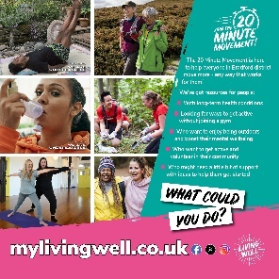
Alt Text | Photo montage showing a man lying on his back doing yoga, two women walking outside on the moors, a woman taking asthma medication using an inhaler, two happy people gardening, two women standing doing yoga poses and two women smiling while out walking. At the top right-hand side on a teal background the 20 Minute Movement logo with text that reads: The 20 Minute Movement is here to help everyone in Bradford district move more - any way that works for them! We’ve got resources for people: With long-term health conditions / Looking for ways to get active that don’t involve joining a gym / Who want to get active and volunteer in their community / Who just need a little bit of support to get started. Visit us to find out more. White rectangles at an angle with black text reads: WHAT COULD YOU DO? Across the bottom of the image: mylivingwell.co.uk social media logos and the Living Well logo
X (Twitter) | 🏃🚶💃🕺🧘🏊🚴  Living with a health condition can make activity challenging, how you feel can change daily. If you're doing stretches or getting up during the adverts - a little goes a long way. Find ideas here https://mylivingwell.co.uk/20-minute-movement/  #20MinMove #WeAreUndefeatable @MyLivingWell1 | 20MM Social Media Landscape 1.jpg  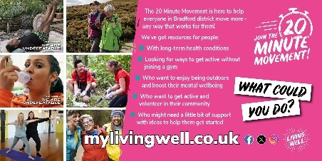
Facebook | 🏃🚶💃🕺🏋️🧘🤸🏊🚴  Living with a health condition can make getting active challenging when how you feel can change day-to-day. But whether you’re working in a stretching routine to your day or getting up from your chair during the ad breaks, a little can go a long way. Find small ways to move more: https://mylivingwell.co.uk/20-minute-movement/  #20MinMove #WeAreUndefeatable @MyLivingWell1 | 20MM Social Media Landscape 1.jpg
Instagram | 🏃🚶💃🕺🏋️🧘🤸🏊🚴  Living with a health condition can make getting active challenging when how you feel can change day-to-day. But whether you’re working in a stretching routine to your day or getting up from your chair during the ad breaks, a little can go a long way. Find small ways to move more: mylivingwell.co.uk  @MyLivingWell1 #WeAreUndefeatable #chronicconditions #betterhealth #HealthAndMovement #ActiveWithConditions #FitnessForHealth #YogaForHealth #MoveWithPurpose #HealthyActiveLifestyle #WalkingWithConditions #MoveMore #FitnessForAll #GetFitTogether #CommunityHealth #VolunteerFitness #ActiveCommunity #HealthyHabits #FitForGood #ExerciseTogether #20MinMove | 20MM Social Media Square 1.jpg
Alt Text | Photo montage showing a man lying on his back doing yoga, two women walking outside on the moors, a woman taking asthma medication using an inhaler, two happy people gardening, two women standing doing yoga poses and two women smiling while out walking. At the top right-hand side on a pink background the 20 Minute Movement logo with text that reads: The 20 Minute Movement is here to help everyone in Bradford district move more - any way that works for them! We’ve got resources for people: With long-term health conditions / Looking for ways to get active that don’t involve joining a gym / Who want to get active and volunteer in their community / Who just need a little bit of support to get started. Visit us to find out more. White rectangles at an angle with black text reads: WHAT COULD YOU DO? Across the bottom of the image: mylivingwell.co.uk social media logos and the Living Well logo
X (Twitter) | 🧘Mahesh finds yoga helps him manage his health conditions. Some days he rolls out of bed and does his workout in his jim-jams! Small amounts of activity can go a long way, find inspiration at: https://mylivingwell.co.uk/20-minute-movement/  #20MinMove #WeAreUndefeatable @MyLivingWell1 | 20MM Social Media Landscape 3.jpg  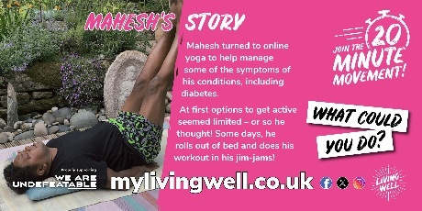
Facebook | 🧘Mahesh finds yoga helps him to manage his health conditions. After diagnosis he thought his options might be limited but some days he rolls out of bed and does his workout in his jim-jams! Even a small amount of activity can go a long way. Find inspiration at https://mylivingwell.co.uk/20-minute-movement/  #20MinMove #WeAreUndefeatable @MyLivingWell1 | 20MM Social Media Landscape 3.jpg
Instagram | 🧘Mahesh finds yoga helps him to manage his health conditions. After diagnosis he thought his options might be limited but some days he rolls out of bed and does his workout in his jim-jams! Even a small amount of activity can go a long way. Find inspiration at mylivingwell.co.uk  #20MinMove #WeAreUndefeatable @MyLivingWell1 #WeAreUndefeatable #chronicconditions #betterhealth #HealthAndMovement #ActiveWithConditions #FitnessForHealth #YogaForHealth #MoveWithPurpose #HealthyActiveLifestyle #WalkingWithConditions #MoveMore #FitnessForAll #GetFitTogether #CommunityHealth #VolunteerFitness #ActiveCommunity #HealthyHabits #FitForGood #ExerciseTogether #yogafit #yogalife #yogajourney #yogagoals #yogapractice | 20MM Social Media Square 3.jpg  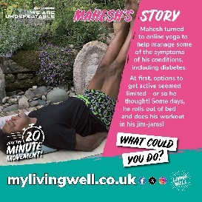
Alt Text: | To the left, a photo of a man lying on his back doing yoga. To the right, a pink background with white text that reads: Mahesh’s Story: Mahesh turned to online yoga to help manage some of the symptoms of his conditions, including diabetes. At first options to get active seemed limited – or so he thought! Some days, he rolls out of bed and does his workout in his jim-jams! White rectangles at an angle with black text reads: WHAT COULD YOU DO? Across the bottom of the image: mylivingwell.co.uk social media logos and the Living Well logo
X (Twitter) | 💃Tania began moving more after treatment for cancer & to manage depression. She says activity isn’t a magic wand, but it really does help! Going for a walk or dancing at home with her daughter, it all adds up! https://mylivingwell.co.uk/20-minute-movement/  #20MinMove #WeAreUndefeatable @MyLivingWell1 | 20MM Social Media Landscape 4.jpg  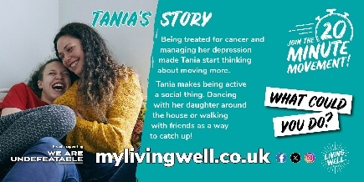
Facebook | 🏃🚶💃🤸Tania started moving more after treatment for cancer and to manage depression. She does things she enjoys and says although activity isn’t a magic wand, it really does help! Going for a walk with friends, a run, or dancing around the house with her daughter all adds up! Find inspiration at https://mylivingwell.co.uk/20-minute-movement/  #20MinMove #WeAreUndefeatable @MyLivingWell1 | 20MM Social Media Landscape 4.jpg
Instagram | 🏃🚶💃🤸Tania started moving more after treatment for cancer and to manage depression. She does things she enjoys and says although activity isn’t a magic wand, it really does help! Going for a walk with friends, a run, or dancing around the house with her daughter all adds up! Find inspiration at mylivingwell.co.uk  #20MinMove #WeAreUndefeatable @MyLivingWell1 #WeAreUndefeatable #chronicconditions #betterhealth #HealthAndMovement #ActiveWithConditions #FitnessForHealth #YogaForHealth #MoveWithPurpose #HealthyActiveLifestyle #WalkingWithConditions #MoveMore #FitnessForAll #GetFitTogether #CommunityHealth #VolunteerFitness #ActiveCommunity #HealthyHabits #FitForGood #ExerciseTogether | 20MM Social Media Square 4.jpg  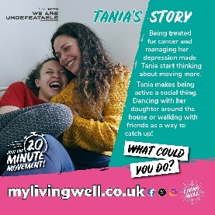
ALT Text | To the left, a photo of a woman cuddling and laughing with her daughter. To the right, a teal background with white text that reads: Tania’s Story: Being treated for cancer and managing her depression made Tania start thinking about moving more. Tania makes being active a social thing. Dancing with her daughter around the house or walking with friends as a way to catch up! White rectangles at an angle with black text reads: WHAT COULD YOU DO? Across the bottom of the image: mylivingwell.co.uk social media logos and the Living Well logo
X (Twitter) | Zahoor made a point of becoming more active after being diagnosed with type 2 diabetes. He enjoys the independence of walking & finds it lowers stress levels & has helped him to sleep better! Find inspiration at https://mylivingwell.co.uk/20-minute-movement/  #20MinMove #WeAreUndefeatable @MyLivingWell1 | 20MM Social Media Landscape 5.jpg  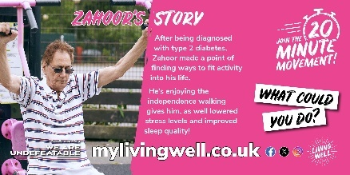
Facebook | 🚶🏋️ Zahoor made a point of becoming more active after being diagnosed with type 2 diabetes. He enjoys the independence of walking and finds it lowers his stress levels and has helped him to sleep better! Find inspiration at https://mylivingwell.co.uk/20-minute-movement/  #20MinMove #WeAreUndefeatable @MyLivingWell1 | 20MM Social Media Landscape 5.jpg
Instagram | 🚶🏋️ Zahoor made a point of becoming more active after being diagnosed with type 2 diabetes. He enjoys the independence of walking and finds it lowers his stress levels and has helped him to sleep better! Find inspiration at mylivingwell.co.uk  #20MinMove #WeAreUndefeatable @MyLivingWell1 #WeAreUndefeatable #chronicconditions #betterhealth #HealthAndMovement #ActiveWithConditions #Diabetes #Type2 #FitnessForHealth #YogaForHealth #MoveWithPurpose #HealthyActiveLifestyle #WalkingWithConditions #MoveMore #FitnessForAll #GetFitTogether #CommunityHealth #VolunteerFitness #ActiveCommunity #HealthyHabits #FitForGood #ExerciseTogether | 20MM Social Media Square 5.jpg  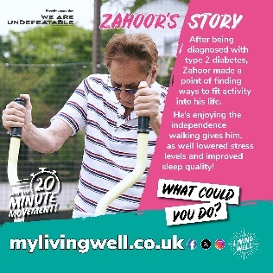
ALT Text | To the left, a photo of a man using an exercise machine outdoors. To the right, a pink background with white text that reads: Zahoor’s Story: After being diagnosed with type 2 diabetes, Zahoor made a point of finding ways to fit activity into his life. He’s enjoying the independence walking gives him, as well lowered stress levels and improved sleep quality! White rectangles at an angle with black text reads: WHAT COULD YOU DO? Across the bottom of the image: mylivingwell.co.uk social media logos and the Living Well logo
X (Twitter) | 🏃Krisina doesn’t allow asthma to limit her or define her. If anything, going for a run on the days she can, has helped her to realise just how strong she can be! Find inspiration at https://mylivingwell.co.uk/20-minute-movement/  #20MinMove #WeAreUndefeatable @MyLivingWell1 | 20MM Social Media Landscape 6.jpg  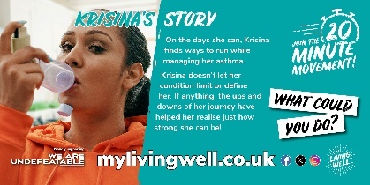
Facebook | 🏃Krisina doesn’t allow asthma to limit her or define her. If anything, going for a run on the days she can, has helped her to realise just how strong she can be! Find inspiration at https://mylivingwell.co.uk/20-minute-movement/  #20MinMove #WeAreUndefeatable @MyLivingWell1 | 20MM Social Media Landscape 6.jpg  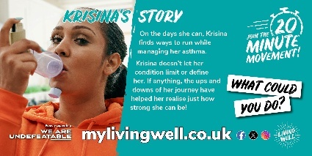
Instagram | 🏃Krisina doesn’t allow asthma to limit her or define her. If anything, going for a run on the days she can, has helped her to realise just how strong she can be! Find inspiration at mylivingwell.co.uk  #20MinMove #WeAreUndefeatable @MyLivingWell1 #WeAreUndefeatable #chronicconditions #betterhealth #HealthAndMovement #ActiveWithConditions #FitnessForHealth #YogaForHealth #MoveWithPurpose #asthma #HealthyActiveLifestyle #WalkingWithConditions #MoveMore #FitnessForAll #GetFitTogether #CommunityHealth #VolunteerFitness #ActiveCommunity #HealthyHabits #FitForGood #ExerciseTogether | 20MM Social Media Square 6.jpg  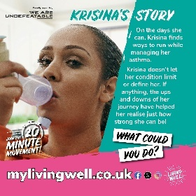
ALT Text | To the left, a photo of a woman taking asthma medication using an inhaler. To the right, a teal background with white text that reads: Krisina’s Story: On the days she can, Krisina finds ways to run while managing her asthma. Krisina doesn’t let her condition limit or define her. If anything, the ups and downs of her journey have helped her realise just how strong she can be! White rectangles at an angle with black text reads: WHAT COULD YOU DO? Across the bottom of the image: mylivingwell.co.uk social media logos and the Living Well logo
X (Twitter) | Would you like to support your community & get active at the same time? Join #GoodGym! Use exercise to make a positive impact where you live! Plant trees/clean up a community centre/sort cans for a foodbank https://www.goodgym.org/  #20MinMove @MyLivingWell1 @GoodGym #GoodGym | 20MM Social Media Landscape 7.jpg  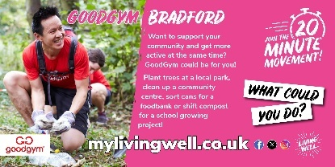
Facebook | 🏃🚶💃🕺🏋️🧘🤸🏊🚴  Would you like to support your community and get more active at the same time? #GoodGym could be for you! It's a community of people who get fit by doing good! Use exercise to make a positive impact in your neighbourhood - you could plant trees at a local park, clean up a community centre, sort cans for a foodbank or shift compost for a school gardening project! Find out more: https://www.goodgym.org/  #20MinMove @MyLivingWell1 @GoodGym #GoodGym  https://mylivingwell.co.uk/20-minute-movement/ | 20MM Social Media Landscape 7.jpg
Instagram | 🏃🚶💃🕺🏋️🧘🤸🏊🚴  Would you like to support your community and get more active at the same time? #GoodGym could be for you! It's a community of people who get fit by doing good! Use exercise to make a positive impact in your neighbourhood - you could plant trees at a local park, clean up a community centre, sort cans for a foodbank or shift compost for a school gardening project! Find out more goodgym.org/  #20MinMove @MyLivingWell1 @GoodGym #GoodGym #betterhealth #HealthAndMovement #FitnessForHealth #HealthyActiveLifestyle #MoveMore #FitnessForAll #GetFitTogether #CommunityHealth #VolunteerFitness #ActiveCommunity #HealthyHabits #FitForGood #ExerciseTogether  mylivingwell.co.uk | 20MM Social Media Square 7.jpg  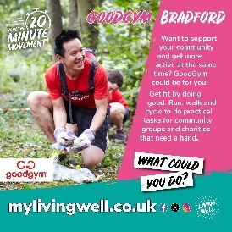
Alt Text | To the left, a photo of a man gardening outside. To the right, a pink background with white text that reads: GoodGym Bradford: Want to support your community and get more active at the same time? GoodGym could be for you! Plant trees at a local park, clean up a community centre, sort cans for a foodbank or shift compost for a school growing project! White rectangles at an angle with black text reads: WHAT COULD YOU DO? Across the bottom of the image: mylivingwell.co.uk social media logos and the Living Well logo
X (Twitter) | Want to support your community & get active at the same time? Join #GoodGym! Get fit by doing good! Run/walk/cycle to do practical tasks for community groups & charities that need a hand https://www.goodgym.org/  #20MinMove @MyLivingWell1 @GoodGym #GoodGym | 20MM Social Media Landscape 8.jpg  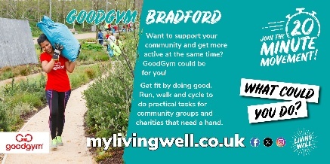
Facebook | 🏃🚶💃🕺🏋️🧘🤸🚴  Would you like to support your community and get more active at the same time? #GoodGym could be for you - it's a community of people who get fit by doing good! Meet like-minded people and use exercise to make a positive impact in your neighbourhood! Run walk and cycle to do practical tasks for community groups and charities that need a hand.  https://www.goodgym.org/  #20MinMove @MyLivingWell1 @GoodGym #GoodGym  https://mylivingwell.co.uk/20-minute-movement/ | 20MM Social Media Landscape 8.jpg
Instagram | 🏃🚶💃🕺🏋️🧘🤸🚴  Would you like to support your community and get more active at the same time? #GoodGym could be for you - it's a community of people who get fit by doing good! Meet like-minded people and use exercise to make a positive impact in your neighbourhood! Run walk and cycle to do practical tasks for community groups and charities that need a hand.  mylivingwell.co.uk  goodgym.org/  #20MinMove @MyLivingWell1 @GoodGym #GoodGym #betterhealth #HealthAndMovement #FitnessForHealth #HealthyActiveLifestyle #MoveMore #FitnessForAll #GetFitTogether #CommunityHealth #VolunteerFitness #ActiveCommunity #HealthyHabits #FitForGood #ExerciseTogether | 20MM Social Media Square 8.jpg  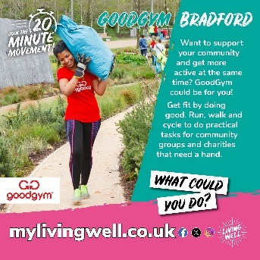
Alt Text | To the left, a photo of a woman carrying a sack on her shoulder outside. To the right, a teal background with white text that reads: GoodGym Bradford: Want to support your community and get more active at the same time? GoodGym could be for you! Get fit by doing good. Run, walk and cycle to do practical tasks for community groups and charities that need a hand. White rectangles at an angle with black text reads: WHAT COULD YOU DO? Across the bottom of the image: mylivingwell.co.uk social media logos and the Living Well logo
X (Twitter) | 🚶Bradford Well Together Service offer a range of health-led walks & other activities led by trained volunteer leaders. The group is for adults and people with long term health conditions are welcomed. Find out more: https://www.bdct.nhs.uk/our-services/mental-health-services/well-together-service/  #20MinMove @MyLivingWell1 @BDCFT_WTS | 20MM Social Media Landscape 9.jpg  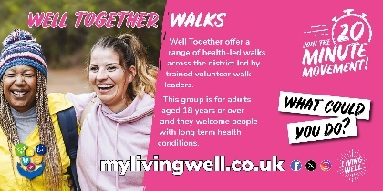
Facebook | 🚶Bradford Well Together Service offer a range of health-led walks and other activities led by trained volunteer walk leaders. The group is for adults aged 18+ and they welcome people with long term health conditions. Find out more: https://www.bdct.nhs.uk/our-services/mental-health-services/well-together-service/  #20MinMove @MyLivingWell1 @BDCFT_WTS  https://mylivingwell.co.uk/20-minute-movement/ | 20MM Social Media Landscape 9.jpg
Instagram | 🚶Bradford Well Together Service offer a range of health-led walks and other activities led by trained volunteer walk leaders. The group is for adults aged 18+ and they welcome people with long term health conditions. Find out more: mylivingwell.co.uk  #20MinMove @MyLivingWell1 @BDCFT_WTS #WalkingGroupFitness #HealthySteps #MoveTogether #StepByStep #GroupFitnessWalks #WalkAndTalk #FitnessFriends #HealthyHikers #OutdoorFitness #Walking | 20MM Social Media Square 9.jpg  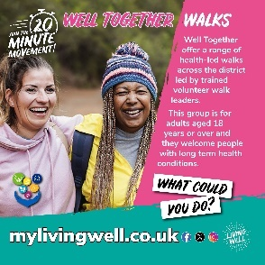
Alt Text | To the left, a photo of two women smiling outdoors. To the right, a pink background with white text that reads: Well Together Walks: Well Together offer a range of health-led walks across the district led by trained volunteer walk leaders. This group is for adults aged 18 years or over and they welcome people with long term health conditions. White rectangles at an angle with black text reads: WHAT COULD YOU DO? Across the bottom of the image: mylivingwell.co.uk social media logos and the Living Well logo
X (Twitter) | 🚶Bradford Well Together Service offer a range of health-led walks & other activities led by trained volunteer leaders. Groups are for adults and people with long term health conditions are welcomed. Find out more: https://www.bdct.nhs.uk/our-services/mental-health-services/well-together-service/  #20MinMove @MyLivingWell1 @BDCFT_WTS | 20MM Social Media Landscape 10.jpg  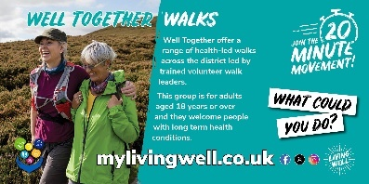
Facebook | 🚶Bradford Well Together Service offer a range of health-led walks and other activities led by trained volunteer walk leaders. Groups are for adults and they welcome people with long term health conditions. Find out more: https://www.bdct.nhs.uk/our-services/mental-health-services/well-together-service/  #20MinMove @MyLivingWell1 @BDCFT_WTS  https://mylivingwell.co.uk/20-minute-movement/ | 20MM Social Media Landscape 10.jpg
Instagram | 🚶Bradford Well Together Service offer a range of health-led walks and other activities led by trained volunteer walk leaders. Groups are for adults and they welcome people with long term health conditions. Find out more: https://www.bdct.nhs.uk/our-services/mental-health-services/well-together-service/  #20MinMove @MyLivingWell1 @BDCFT_WTS #WalkingGroupFitness #HealthySteps #MoveTogether #StepByStep #GroupFitnessWalks #WalkAndTalk #FitnessFriends #HealthyHikers #OutdoorFitness #Walking  mylivingwell.co.uk | 20MM Social Media Square 10.jpg  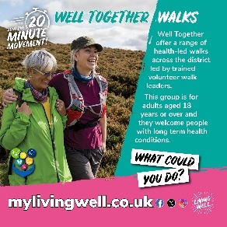
Alt Text | To the left, a photo of two women smiling and walking across the moors outdoors. To the right, a teal background with white text that reads: Well Together Walks: Well Together offer a range of health-led walks across the district led by trained volunteer walk leaders. This group is for adults aged 18 years or over and they welcome people with long term health conditions. White rectangles at an angle with black text reads: WHAT COULD YOU DO? Across the bottom of the image: mylivingwell.co.uk social media logos and the Living Well logo
X (Twitter) | Staying strong does more than build muscle, it can boost your mood, improve sleep, support a healthy weight and increase confidence. Start small – visit us to find simple exercises you can do at home!  https://mylivingwell.co.uk/stronger-for-longer-exercises/  #20MinMove @MyLivingWell1 | 20MM Social Media Landscape 11.jpg  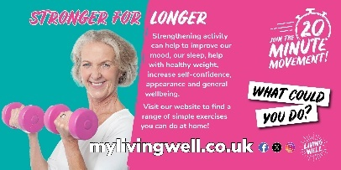
Facebook | Staying strong does more than build muscle, it can boost your mood, improve sleep, support a healthy weight and increase confidence. Start small – visit us to find simple exercises you can do at home!  https://mylivingwell.co.uk/stronger-for-longer-exercises/  #20MinMove @MyLivingWell1 | 20MM Social Media Landscape 11.jpg
Instagram | Staying strong does more than build muscle, it can boost your mood, improve sleep, support a healthy weight and increase confidence. Start small – visit us to find simple exercises you can do at home!  mylivingwell.co.uk  #20MinMove #Exercise #Over40 #FitForLife #HealthyLifestlye #StayStrong #Wellbeing | 20MM Social Media Square 11.jpg  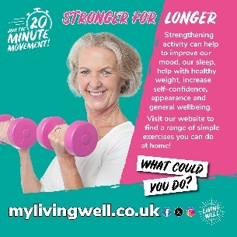
Alt Text | To the left, a photo of a women over the age of 40 smiling into the camera and holding two pink weights. To the right, a pink background with white text that reads: Stronger For longer: Strengthening activity can help to improve our mood, our sleep, help with healthy weight, increase self-confidence, appearance and general wellbeing. Visit our website to find a range of simple exercises you can do at home! White rectangles at an angle with black text reads: WHAT COULD YOU DO? Across the bottom of the image: mylivingwell.co.uk social media logos and the Living Well logo
X (Twitter) | Strengthening activities can help manage health conditions & lower risks of others. In our 40s muscle loss begins, but it’s never too late to build strength & take control of your health. Get started with exercises at home today! https://mylivingwell.co.uk/stronger-for-longer-exercises/  #20MinMove @MyLivingWell1 | 20MM Social Media Landscape 12.jpg  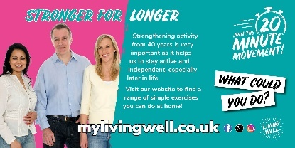
Facebook | Strengthening activities can help manage health conditions and lower the risk of others. In our 40s, muscles loss begins, but it’s never too late to build strength and take control of your health. Get started with easy exercises you can do at home today! https://mylivingwell.co.uk/stronger-for-longer-exercises/  #20MinMove @MyLivingWell1 | 20MM Social Media Landscape 12.jpg
Instagram | Strengthening activities can help manage health conditions and lower the risk of others. In our 40s, muscles loss begins, but it’s never too late to build strength and take control of your health. Get started with easy exercises you can do at home today!  mylivingwell.co.uk  #20MinMove #Exercise #Over40 #FitForLife #HealthyLifestlye #StayStrong #Wellbeing #LongTermConditions | 20MM Social Media Square 12.jpg  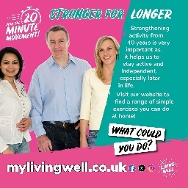
Alt Text | To the left, a photo of a group of people over the age of 40 smiling into the camera. To the right, a teal background with white text that reads: Stronger For longer: Strengthening activity from 40 years is very important as it helps us to stay active and independent, especially later in life. Visit our website to find a range of simple exercises you can do at home! White rectangles at an angle with black text reads: WHAT COULD YOU DO? Across the bottom of the image: mylivingwell.co.uk social media logos and the Living Well logo
X (Twitter) | 🧘💃Frances became inactive & gained weight in lockdown. Signing up for yoga, dance classes & our FREE Slimming World offer helped her take back control & boost her wellbeing. She says she feels fitter at 60 than she did at 50! https://mylivingwell.co.uk/news-post/frances-has-joined-the-20-minute-movement/  #20MinMove @MyLivingWell1 | 20MM Social Media Landscape 13.jpg  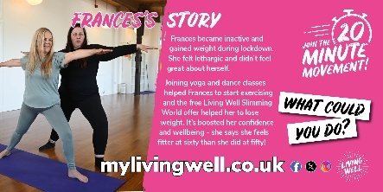
Facebook | 🧘💃 Frances became inactive and gained weight during lockdown. She didn't feel great about herself and felt lethargic. Signing up for yoga, dance classes & our FREE Slimming World offer, helped her to take back control. It’s boosted her confidence and wellbeing. Frances says she feels fitter now at 60 than she did at 50! https://mylivingwell.co.uk/news-post/frances-has-joined-the-20-minute-movement/  #20MinMove @MyLivingWell1 | 20MM Social Media Landscape 13.jpg
Instagram | 🧘💃 Frances became inactive and gained weight during lockdown. She didn't feel great about herself and felt lethargic. Signing up for yoga, dance classes & our FREE Slimming World offer, helped her to take back control. It’s boosted her confidence and wellbeing. Frances says she feels fitter now at 60 than she did at 50! mylivingwell.co.uk  #20MinMove @MyLivingWell1 #yogafit #yogalife #yogajourney #yogagoals #yogapractice #SlimmingWorld | 20MM Social Media Square 13.jpg  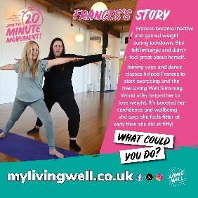
Alt Text | To the left, a photo of a yoga instructor showing a women how to do a standing yoga pose. To the right, a pink background with white text that reads: Frances’s Story: Frances became inactive and gained weight during lockdown. She felt lethargic and didn’t feel great about herself. Joining yoga and dance classes helped Frances to start exercising and the free Living Well Slimming World offer helped her to lose weight. It’s boosted her confidence and wellbeing - she says she feels fitter at sixty than she did at fifty! White rectangles at an angle with black text reads: WHAT COULD YOU DO? Across the bottom of the image: mylivingwell.co.uk social media logos and the Living Well logo
X (Twitter) | 🚶Ellen walked to school with her son and to work before lockdown. Working from home meant she had less reason to walk. She's not keen on the gym so she joined our 20 Minute Movement walking each day & started litter picking too! https://mylivingwell.co.uk/20-minute-movement/  #20MinMove @MyLivingWell1 | 20MM Social Media Landscape 14.jpg  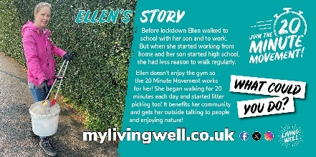
Facebook | 🚶Ellen used to walk to school with her son and then to work before lockdown. When she started working from home, she had less reason to walk but wanted to increase her activity levels. Ellen isn’t keen on the gym, so she started walking for 20mins each day and then started litter picking too! It benefits her community and gets her outside talking to people and enjoying nature! https://mylivingwell.co.uk/20-minute-movement/  #20MinMove @MyLivingWell1 | 20MM Social Media Landscape 14.jpg
Instagram | 🚶Ellen used to walk to school with her son and then to work before lockdown. When she started working from home, she had less reason to walk but wanted to increase her activity levels. Ellen isn’t keen on the gym, so she started walking for 20mins each day and then started litter picking too! It benefits her community and gets her outside talking to people and enjoying nature! mylivingwell.co.uk  #20MinMove @MyLivingWell1 #LitterPick #CommunityClean #FitForCleanUp #CleanUpCrew #PickingForGood #HealthyCommunity #LitterLotto | 20MM Social Media Square 14.jpg  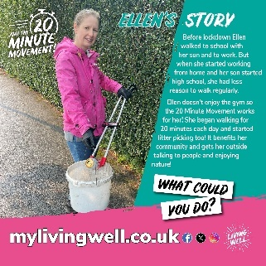
Alt Text | To the left, a photo of a woman outside litter picking. To the right, a teal background with white text that reads: Ellen’s Story: Before lockdown Ellen walked to school with her son and to work. But when she started working from home and her son started high school, she had less reason to walk regularly. Ellen doesn’t enjoy the gym so the 20 Minute Movement works for her! She began walking for 20 minutes each day and started litter picking too! It benefits her community and gets her outside talking to people and enjoying nature! White rectangles at an angle with black text reads: WHAT COULD YOU DO? Across the bottom of the image: mylivingwell.co.uk social media logos and the Living Well logo

